An Investigation in the use of Mobile Applications with Location Tracking to improve the quality of life for Dementia Patients and their Carers

Joseph Schofield

000776975

Project Supervisors: Mrs Keeran Jamil & Ms Maria Pretorius

**Final Year Individual Project COMP1682**

A report submitted in partial fulfilment of the University of Greenwich’s

BSc (Hons) Computing

Word Count: 14,152

Due date: 24/04/2017

1. Abstract

This report will investigate the uses of mobile technology with people with Dementia and their carers to deduce a way in which the technology can be improved, particularly to reduce the occurrence and risks of wandering. The product of this project will be two applications - one for the person with Dementia, one for the carer - which can be used to track the person with Dementia and enable them to navigate themselves home with relative ease.

1. Acknowledgements

I would like to thank Mrs Keeran Jamil for all her help throughout this project. Including lectures, tutorials and for being extremely helpful with my multitude of queries.

I would also like to thank Ms Maria Pretorius for her advice and guidance throughout the tutorial sessions.

Furthermore, I wish to show my gratitude to Dr Ralph Barthel for providing interesting and insightful viewpoints in my selection of technologies to use in my project.

I would like to thank Ms Karen Richardson for her time and assistance in finding research articles for the literature review chapter.

One more member of the university that I would like to thank is Dr Markus Wolf, who has sent me countless emails assisting me with the development of my project.

Finally, I’d like to thank my fiancée, family, and friends - all of whom have been invaluable throughout this project. Thank you all for offering advice, imparting knowledge, and for just being there.

1. Contents

i. Abstract 1

ii. Acknowledgements 2

iii. Contents 3

1. Introduction 8

1.1. Abstract 8

1.2. Aim 8

1.3. Objectives 9

1.3.1. Research 9

1.3.2. Design Documentation 9

1.3.3. Implementation 10

1.3.4. Evaluation Report 10

1.4. Approach 11

2. Literature Review 12

2.1. Location Based Services in Android Application Development 12

2.1.1. What are Location Based Services? 12

2.1.2. Development of LBS 12

2.1.3. How to use LBS 13

2.1.4. Uses of LBS 13

2.2. Wandering in People with Dementia 13

2.2.1. What is wandering? 13

2.2.2. Percentage of People with Dementia Who Wander 14

2.2.3. Causes 14

2.2.4. Dangers 14

2.2.5. Preventative Measures and Cures 15

2.2.5.1. Music Therapy 15

2.2.6. Use of Technology in People with Dementia and their Carers 16

2.3. Conclusion 17

3. Product Comparison 17

3.1. Method of Comparison 18

3.2. Heuristic Comparison 18

3.3. Differences to Proposed Application 27

4. User Personas 29

4.1. Patient 29

4.2. Family of Patient 30

4.3. Carer 31

5. Technical Review 32

5.1. Platform Selection 32

5.2. Selection of IDE 33

5.3. Shared Preferences 35

5.4. Legal, Social, Ethical & Professional Issues 35

6. Design Specification 37

6.1. Non-functional Requirements 37

6.2. Functional Requirements 38

6.3. MVP 40

6.4. UML Diagrams 40

6.5. Class Diagrams 40

6.5.1. PatientTrack for Carers 40

6.5.2. PatientTrack for Patients 41

6.6. ERDs 42

6.6.1. Conceptual ERD 42

6.6.2. Logical ERD 43

6.6.3. Physical ERD 44

6.7. Sequence Diagrams 45

6.7.1. PatientTrack for Carer - Adding new patient 45

6.7.2. PatientTrack for Patient - Clicking lost button 46

6.8. Use Case Diagrams 47

6.8.1. PatientTrack for Carers 47

6.8.2. PatientTrack for Patients 48

6.9. Deployment Diagrams 49

6.10. State Machine Diagrams 50

7. User Interface Design 51

7.1. Wireframe Low-Fidelity Prototypes 51

7.1.1. Carer App 1 51

7.1.2. Carer App 2 53

7.1.3. Patient App 1 55

7.1.4. Patient App 2 57

7.2. Feedback 58

7.3. Colour Scheme and Font Selection 59

7.4. High Fidelity Prototype 60

7.4.1. Carer App 60

7.4.2. Patient App 63

8. Implementation 66

8.1. Development Issues 66

8.2. Prototypes 66

8.2.1. Prototype 1 67

8.2.2. Prototype 2 67

8.2.3. Prototype 3 67

8.2.4. Prototype 4 68

8.3. Differences to Original Design 69

8.3.1. Updated Physical Data Model 69

8.3.2. Updated PatientTrack for Carers Class Diagram 70

8.3.3. Updated PatientTrack for Patients Class Diagram 71

8.3.4. Updated Deployment Diagram 72

8.4. Functionality 73

8.5. Implementation from Designs 73

8.6. Interim Testing 73

8.7. Legal, Social, Ethical, and Professional Considerations 75

9. Testing 76

9.1. Testing Method 76

9.1.1. Manual / Black Box Testing 76

9.1.2. Questionnaires to Colleagues 76

9.1.3. Unit Testing 76

9.2. Testing Prototypes 77

9.2.1. Prototype 1 77

9.2.2. Prototype 2 77

9.2.3. Prototype 3 78

9.2.4. Prototype 4 79

9.3. Legal, Social, Ethical, and Professional Considerations in Testing 79

10. Evaluation 80

10.1. Heuristic Evaluation 80

10.2. Requirements Evaluation 81

10.3. Future Development 82

11. Critical Appraisal 83

11.1. Process Evaluation 83

11.2. Author Evaluation 84

12. Conclusion 85

13. References 86

14. Bibliography 89

15. Appendices 90

A. System Functionality 90

A.1. PatientTrack for Carers 90

A.1.1. Registration 90

A.1.2. Login 92

A.1.3. Help 93

A.1.4. Privacy Policy 94

A.1.5. Home 95

A.1.6. Settings 96

A.1.7. Change Password 97

A.1.8. Patient Details 98

A.1.9. Patient Settings 99

A.2. PatientTrack for Patients 100

A.2.1. Register 100

A.2.2. Login 101

A.2.3. Help 102

A.2.4. Privacy Policy 103

A.2.5. Home 104

A.2.6. Navigation (Google Maps) 105

A.2.7. Settings 106

A.2.8. Change Password 107

B. Requirements Evaluation 108

B.1. Non-functional Requirements Evaluation 108

B.2. Functional Requirements Evaluation 110

C. Notable code 118

C.1. PatientTrack for Carers 118

C.1.1. Viewing Patient Details 118

C.1.2. Delete Account 119

C.1.3. Changing Password 120

C.2. PatientTrack for Patients 121

C.2.1. Patient Code Generation 121

C.2.1. No Data Connection 122

C.2.2. Uploading the location 124

C.2.3. Navigation 125

D. Surveys 126

D.1. Prototype 1 126

D.2. Prototype 2 127

D.3. Prototype 3 128

D.4. Prototype 4 129

E. Test logs 130

E.1. Prototype 1 130

E.1.1. PatientTrack for Patients 130

E.1.2. PatientTrack for Carers 132

E.2. Prototype 2 134

E.2.1. PatientTrack for Patients 134

E.2.2. PatientTrack for Carers 135

E.3. Prototype 3 136

E.3.1. PatientTrack for Patients 136

E.3.2. PatientTrack for Carers 138

E.4. Prototype 4 140

E.4.1. PatientTrack for Patients 140

E.4.2. PatientTrack for Carers 143

F. Project Proposal 147

1. Introduction
   1. Abstract

According to the Alzheimer’s Society (2016), *“there are 850,000 people with dementia in the UK, with numbers set to rise to over 1 million by 2025”*. As the number of patients increases, so does the pressure on their carers (Cipriani et al, 2014), therefore something must be done to reduce the workload of a Dementia carer. This project will investigate how we utilise technology to assist the lives of Dementia sufferers and their patients to determine what more we can do with it. Currently people suffering from Dementia are very dependent on their carers as the disease can cause them to get confused and lost quite easily (Holzer & Warshaw, 2009). Furthering this point, Kwok et al (2009) wrote *“patients with greater cognitive decline and continued mobility are at greater risk of getting lost”*. Cipriani et al (2014) calculated that 1 in 5 (20%) people with Dementia wander, whereas Kwok et al (2009) state that *“their data showed that 37.7% of the patients had history of wandering”*. While it is arguable that the figure may have declined since 2009, there is no doubt that wandering remains a serious issue, causing increased morbidity or even mortality (Cipriani et al, 2014).

This project intends to investigate how severely this issue affects the day to day life of Dementia sufferers and their carers. It will also explore any other issues which have not yet had solutions created. A solution to these issues will be found by analysing the many white papers and articles available and finding common issues (Dementia sufferers should not be contacted directly as it is not ethically viable). From discovery of these issues, a system will be designed which resolves them (or reduces their effect), beginning with the most important issue first. Once a solution has been determined and created it can be evaluated by comparing qualities of the application to similar applications - testing features such as ease of use, simplicity of design and returning to the original problem domain to test that the application resolves the issues.

**Keywords:**

Android, Application, Dementia, Location-tracking, Smartwatch, Smartphone, Assistive Technologies

* 1. Aim

This project aims to explore the current issues surrounding Dementia sufferers and their carers to gather requirements to develop an Android application which will simplify the process of caring for the Dementia sufferers.

* 1. Objectives
     1. Research

|  |  |
| --- | --- |
| **1.3.1.1** | Gain an improved understanding of Android development and Dementia to understand what application would be useful |
| **1.3.1.2** | Read papers relevant to Android Development using location services. [1] |
| **1.3.1.3** | Read papers relevant to the use of technology with Dementia sufferers. [1] |
| **1.3.1.4** | Read papers detailing the issues that Dementia Patient Carers encounter. [1] |
| **1.3.1.5** | Research papers and websites to discover legal issues surrounding Android applications. [0.5] |
| **1.3.1.6** | Research ethical issues surrounding working with Dementia sufferers. [0.5] |
| **1.3.1.7** | Find similar mobile applications currently available and determine how this project’s solution is different. [1] |

* + 1. Design Documentation

|  |  |
| --- | --- |
| **1.3.2.1** | Fully design the application using UML diagrams and high-fidelity prototyping. |
| **1.3.2.2** | Create a Statement of Requirements [2] |
| **1.3.2.3** | Design a low-fidelity prototype on paper [0.5] |
| **1.3.2.4** | Create Use Case diagram with at least 5 use cases [1.5] |
| **1.3.2.5** | Create Class Diagram [0.5] |
| **1.3.2.6** | Create State Diagram [0.5] |
| **1.3.3.7** | Research Android user interface design [1] |
| **1.3.2.8** | Design database [0.5] |
| **1.3.2.9** | Prioritise requirements using MoSCoW analysis [1] |

* + 1. Implementation

|  |  |
| --- | --- |
| **1.3.3.1** | Develop the Android smartphone applications |
| **1.3.3.2** | Create a GitHub repository and set up local workspace [0.1] |
| **1.3.3.3** | Create simple web database for storing user details [0.5] |
| **1.3.3.4** | Create blank projects for Android platform [0.1] |
| **1.3.3.5** | Develop applications in Ionic framework (HTML, CSS & AngularJS) [20] |
| **1.3.3.6** | Develop test plan [2] |
| **1.3.3.7** | Carry out testing [2] |

* + 1. Evaluation Report

|  |  |
| --- | --- |
| **1.3.4.1** | Critically evaluate the final product. |
| **1.3.4.2** | Check that requirements have been met, and explain reasons for any that haven’t. [2] |
| **1.3.4.3** | Describe any future developments of the application [0.5] |
| **1.3.4.4** | Explain any changes that would be made to the finished product in the future [0.5] |

* 1. Approach

As with all projects, implementing a specific methodology will improve the likelihood of the project being a success. An iterative process is very important here as there is such a short amount of time to complete the project in. Furthermore, it is suited to this project as the problem and requirements are well understood. Therefore, a Waterfall style methodology such as SSADM will not be used. For this project, DSDM Atern will be used as this is a framework (as opposed to methodology) which promotes:

* MoSCoW analysis of requirements
  + This will help in selecting which features to develop initially
* Timeboxing
  + This will ensure that all features are developed within the time scale
* Prototyping
  + The use of prototypes will assist in viewing several different user interfaces for the application to enable the selection of one which is most suitable.
* Iterative Development
  + This project will develop, and build upon, prototypes of the system, adding functionality in stages. This will ensure that after each timebox that a functioning system is available to test.

In conclusion, DSDM practises and tools will be used where possible in this project as this seems to be the most suitable framework and this will increase the chance of the project being a success.

1. Literature Review

The purpose of this literature review is to investigate and discuss the topics surrounding this project - namely location based services in Android application development and wandering in people with Dementia.

* 1. Location Based Services in Android Application Development
     1. What are Location Based Services?

Techopedia (2016), define LBS as “*services offered through a mobile phone and take into account the device’s geographical location.*”. This concurs with Schiller & Voisard (2004), who state that “*Location services can be defined as services that integrate a mobile device’s location or position with other information so as to provide added value to the user.*”. Kosta et al (2008), state that *“[the term LBS] appeared in the end of the 1990s and is used for applications that leverage the user‘s physical location to provide an enhanced service or experience”*. Ryschka et al (2016), further explain that *“the advent of LBS was predominantly determined by the E911 mandate issued by the Federal Communications Commission in the United States in 1996.”*. This was a mandate to improve emergency services by displaying a more accurate location of the caller’s location.

* + 1. Development of LBS

LBS, like most technologies, has developed enormously and improved in recent years. Chen & Lin (2011), explain that initially it was frustrating to gain the location of a device as the only method of connection was via a 2G network which was restricted to an extremely slow 9.6kb/s. They go on to state how this *“severely limits the richness of the information and the complexity of the wireless data services and applications being offered.”*. However, Lambture & Shaikh (2016), suggest that this has now improved, stating that *“Location-awareness anywhere anytime is no longer a fiction, but a reality.”*. Chen & Lin (2011), put this down to the creation of the 3G network.

* + 1. How to use LBS

To enable the use of LBS with Android devices some criteria must be met: The user’s phone must have an internet connection (either via WiFi or cellular data) and the user’s phone must have location services enabled (summarised from Lambture and Shaikh, 2016). Zickuhr (2012), states that *“74% of Smartphone owners use their phone to get real-time location-based information”,* however a more recent article from GeoMarketing (2016), suggests that the number is closer to 90% - suggesting that an increasing number of smartphone owners use LBS.

* + 1. Uses of LBS

LBS has a plethora of uses, Kosta et al (2008), state some of these as *“route guidance, location of stolen or missing property, tourist and weather information, etc.”.*  Chen & Lin (2011), concur, stating some uses as *“local information checking (e.g., navigation and local weather forecasting) and providing entertainment guide (locating stores and finding friends).”* LBS were originally developed for the US military, however in the 1980s the US government made the positioning data freely available to other industries worldwide (paraphrased from Kosta et al (2008)).

* 1. Wandering in People with Dementia
     1. What is wandering?

Wandering is a behavioural symptom of Dementia. Algase et al (2007), define Wandering (in terms of Dementia) as *“A syndrome of dementia-related locomotion behaviour having a frequent, repetitive, temporally-disordered and/or spatially-disoriented nature that is manifested in lapping, random and/or pacing patterns, some of which are associated with eloping, eloping attempts or getting lost unless accompanied.”*, although there is currently no universally accepted definition (Yamakawa et al, 2014; Cipriani et al, 2014). Desai et al (2012), explain that *“[behavioural symptoms] are often persistent, [and] greatly diminish quality of life of patients and their family caregivers.”*, Yamakawa et al (2014), further this point, saying *“Wandering is one of the most difficult behavioural psychological symptoms of dementia”*. Evidently wandering is an enormous issue for people with Dementia, their carers and their families and there is a lot of scope for improving the current situation.

* + 1. Percentage of People with Dementia Who Wander

Cipriani et al (2014), found that *“A 2006 study reported that one in five people with dementia wander, but estimates of the prevalence of wandering vary, with rates having been reported as 17.4% in community-residing seniors, 50% in severe dementia, and 63% in community dwellers.”.* These numbers are alarmingly high, and a huge cause for concern among carers and families of Dementia patients. Kwok et al (2009), and Yamakawa et al (2014), evaluate that wandering does not just put extra stress on the carers of people with dementia but can be traumatic for the person wandering. It is therefore imperative that the chances of wandering occurring are reduced as much as possible.

* + 1. Causes

Although wandering is such a severe issue, there has been very little research into the cause and treatment. Yamakawa et al (2014), state that *“its cause and treatment have not been evaluated with objective measurements to date.”.* There has been much speculation as to the causes, including confusion, fear, boredom, and tension (Klein et al, 1999; Cohen‐Mansfield & Billig, 1986). Desai et al (2012), list some of the potential contributing factors to behavioural symptoms of dementia (including wandering) as medications, medical conditions, environmental factors, psychosocial factors, and factors relating to poor caregiving. Evidently no single cause of wandering has been determined. Alternatively, there may be many factors which can trigger wandering in the person with Dementia.

* + 1. Dangers

The main causes of death among people with Dementia are bronchopneumonia (38.4%) and ischaemic heart disease (23.1%) (Brunnström, H.R. & Englund, E.M., 2009). However, wandering can cause fatality among people with Dementia - according the Alzheimer’s Association (2016), *“More than 60 percent of those with Alzheimer’s or another form of dementia will wander, and if a person is not found within 24 hours, up to half of individuals who wander will suffer serious injury or death.”*. Cipriani et al (2014), agree, stating that *“[wandering in people with Dementia] has been associated with negative consequences such as higher morbidity and mortality.”.* Furthermore, Matthews (2015), claims that *“Dementia is now a leading cause of both mortality and morbidity”*.

* + 1. Preventative Measures and Cures

As previously stated, wandering has an enormous impact not just on the person with Dementia, but also their family and Carers (Desai et al, 2012). Naturally it is logical to attempt to prevent wandering before it occurs. The Alzheimer’s Association (2016), explain a few methods which carers and family member can employ to avert a bout of wandering. These include ensuring the person with Dementia is content, placing deadbolts in difficult to reach places on doors, and avoiding busy places such as shopping malls.

While prevention may stop isolated incidents of wandering, it does not cure the impulse of the person with Dementia. There are several non-pharmacological interventions available, although the efficacy of them has been debated. Robinson et al (2006), state that some of these interventions are *“walking/exercise, music therapy (most acceptable), aromatherapy, massage, multi-sensory environments and environmental modifications/design (acceptable).”.*

* + - 1. Music Therapy

As music therapy is claimed (by Robinson et al, 2006), to be the most acceptable form of non-pharmacological intervention, it has been investigated further.

The American Music Therapy Association (2016), describe music therapy as *“the clinical and evidence-based use of music interventions to accomplish individualized goals within a therapeutic relationship by a credentialed professional who has completed an approved music therapy program.”*. McDermott et al (2014), claim that *“Music-based interventions including music therapy, community singing groups and music listening are widely accepted as beneficial for the psychological well-being of people with dementia.”*. Conversely, Robinson et al (2006), reviewed a study comparing music therapy to reading therapy as a control intervention. They found that there was no evidence that music therapy reduced wandering in people with Dementia. Yamakawa et al (2014), agree with Robinson et al (2006), stating that *“evidence for treating wandering with non-pharmacological interventions such as music therapy is weak.”*. Matthews (2015), explains that the success of music therapy is associated with *“the communal nature of its delivery, the rhythmic quality of composition, the entrancing effect of music’s mood, and the physiological arousal accompanying listening.”*, going on to conclude that music therapy is a cost-effective, non-pharmacological social activity which can temporarily enable people with dementia to appear as they were before.

* + 1. Use of Technology in People with Dementia and their Carers

Díaz-Ramírez et al (2013), tell us that *“the aging of the world population has motivated the development of ambient intelligence solutions to assist the elderly.”* These solutions are mostly built to be used by carers to assist the elderly. According to Kwok et al (2009), the average age of a Dementia sufferer is 78 years old. The majority of people in this age group do not have much experience with smartphone technologies. Smith (2014), states that just 10% of people aged 75-79 own a smartphone, although 20% own a tablet or e-book - so may have experience with technology similar to that of a smartphone (i.e. iPads and iPhones have a similar UX). It is therefore why many of the available products used for locating people with Dementia (discussed further in the product comparison chapter of this report) require little or no user interaction.

Maiden et al (2013), explain that managers of residential homes do not always have the skills required to introduce modern technology to their residents, and that doing so can put extra pressure on the carers. They go on to conclude that different care homes may have different care strategies, so an app which is developed to be used across the board must be aware of, and allow for, these differences.

An issue with developing a smartphone application is that - while the carer will normally have the phone with them - the person with dementia may not remember to carry the phone, or may lose the phone. Sasaki (2016), explains that *“not a large number of the-state-of the art solutions are designed to care of the signs of” “difficulty performing familiar tasks”* and/or *“misplacing things”*. Oh & Gross (2015), state that the elderly tend to avoid using assistive technologies (such as smartphones), but even if they do they *“may forget to carry them or lose the device.”*. Furthermore, Shree et al (2014), list “*misplacing things”* as a symptom of Alzheimer’s Disease (a form of Dementia).

Family members can find it difficult to care for a relative who has dementia. The Family Caregiver Alliance (2016), state that *“family members who live far away can feel frustrated that they do not have the opportunity to participate more in providing care”.* Improvements in technology have improved the situation dramatically, as family members can now track their relatives remotely so can feel more comfortable that they are in a safe place - or that they can help them if they aren’t. Maiden et al (2013), claim that *“digital technology could potentially improve the quality of care”.* This technology can be used for more than just tracking on an ad hoc basis - it could also be used as an alert system. Milne et al (2014), explain how the device could be set up to *“allow the person to move appropriately through familiar areas”, “but will set off an alert if this geo-temporal limit (or “geo-fence”) is breached”*.

* 1. Conclusion

The “Location Based Services in Android Application Development” section of this literature review helped to gain a better understanding of what location based services are and the various features that the applications will have to include to be able to use the location of a device, such as ensuring permission is granted to access the GPS location. The figures of people with location-enabled smartphones that use location services are not extremely positive, and increasingly so. This has reassured that the application developed will be based on technology which will certainly be around for many years to come. One concern is the reliability of a connection and reliability of data received from GPS enabled devices, however Chen & Lin (2011), thoroughly explain how this has improved which suggests that it will only continue to improve with the increased coverage of 4G and eventually 5G connections.

The “Wandering in People with Dementia” section of this literature review demonstrated the severity and impact of Dementia on people with the disease and their families. The number of people with Dementia who wander is incredibly high and a review of the dangers of this is concerning. However, this does mean that there is call for an application which can assist people with Dementia and their carers to avoid the dangers of wandering. Robinson et al (2006) mentioned a very interesting non-pharmacological treatment of Dementia - music therapy. This is something which could be very valuable to incorporate within the application, however I’m not sure that the project will allow enough time to create this - in which case it may be included as a ‘won’t have’ requirement from a MoSCoW analysis. This literature review also discussed the lack of proficiency the elderly have with technology, therefore the application developed as the product of this project must have an especially simple UI with as few ‘hands-on’ features as possible for the person with Dementia. To simplify the experience further it would be brilliant to use a ‘widget’ (a miniature application which runs on the home screen of a smartphone) of this application so that less navigation is required. The carers of people with Dementia may also not be particularly capable of using complex technology so the carer’s app should not be overly complex.

1. Product Comparison

This section investigates products which are similar to the project idea. The application will be developed initially for Android (for justification see **4.1**). Therefore, a review mobile apps which have similar functionality, or resolve a similar issue, has been completed. Research has not been limited to the Google Play Store to explore the possibility of creating a hybrid application (see **4.1**) as this will make porting to iOS much easier. Therefore, apps which are on the Apple App Store have been researched in addition to the Google Play Store.

* 1. Method of Comparison

To compare the proposed application against similar available solutions, the applications have been evaluated using Nielsen’s 10 Heuristics. Usability.gov (2016), describe Nielsen’s heuristics as *“one of the best-known sources”* of heuristics. They also explain that a heuristic evaluation is a method of obtaining *“quick and relatively inexpensive feedback to designers”.*

* 1. Heuristic Comparison

The heuristics below were created by Jakob Nielsen in 1994. (Nielsen, 1995). Current available products have been analysed to investigate how much they adhere to these heuristics. They have then been compared to the proposed product in the table below.

|  |  |  |  |  |
| --- | --- | --- | --- | --- |
| **Product** | Medicgeo *(Android)* | Family Locator - GPS Tracker *(Android)* | Google Maps *(Android)* | Find my iPhone *(iOS)* |
| **Heuristic** |
| Visibility of system status | The app is very good at showing what the app is doing. It has a timer which shows when the location was last updated and the patient’s status (moving/stationary, battery level, location). | This heuristic is adhered to exceptionally within this application. It shows when the location was last updated, where the device is (using a map) and if the device is still connected. | Google Maps gives the user constant feedback as it displays the user’s location on the map. It also shows if results are live for directions including traffic and train delays. | This app shows where each device linked to the account is located, when the data was last received, and a coloured circle to show if each device is online. |
| Match between system and the real world | This is done very poorly within this app. In some parts the text is written in German. However, the helper app allows the carer to set a picture of the patient they are tracking to make it easier to determine who is who. | Family locator uses language and images which are very well matched to the real world. Each person on the map can set a profile picture so they can be easily recognised. It also uses a map which corresponds exactly to the real location of the person’s device. Furthermore, all language used within the app is very clear and familiar. | This application matches the real world very well as the map contains real world buildings, parks, fields, etc. The system also allows the user to search for places by typing into a search box which says, ‘Search here’. | Similar to the other applications, this application uses a map to portray the real world, and also uses the user’s system language. |
| User control and freedom | The patient app has very little functionality so once it’s set up it the only way the user can leave the page is by selecting settings. The user can then return by simply hitting the back button. However, in the helper app There are a lot of functions, some of which change the contents of the screen. There is no obvious button to immediately return to the previous screen here. | This app does this very well - with every function available to the user hitting the ‘back’ button on the phone will return the user to the previous screen. | With all functions of this application if the user is taken to a separate page (i.e. a list of directions) there is a persistent ‘back’ button which allows the user to return to the map home page. | The app has a ‘wipe device’ function - something which once done, cannot be undone (although there are sufficient confirm messages). However other features such as ‘lost mode’ and ‘play sound’ can be cancelled at any time. |
| Consistency and standards | In the patient app, the functions are very clear. The home page has 3 large buttons to report to the carer how the user is (fine, requires picking up, requires help). These are clearly labelled with widely recognised icons. The helper app’s icons used are very intuitive, such as using an arrow for directions and a GPS ‘target’ icon for locating a patient. | The app has mostly very clear functionality. All icons are consistent with what is used in most Android apps. The app does not have words or actions which may confuse the user into thinking they are the same thing. The only two features that some less experienced users may find confusing are an ‘AR’ (Augmented Reality) button which shows the location of devices in AR, and a button which toggles between satellite and normal map. These icons may not be known by less experienced users but are very easy to understand once used. | As Google are the creators of the Android platform they are the creators of many of the platform standards. As such the icons, text and layouts used with Google Maps are familiar to all Android users. | The app adheres to apple UI guidelines. All functions are very clearly shown, and require no explanation due to straightforward wording. |
| Error prevention | This has been handled very well in both the patient and carer apps. No errors have been encountered by testing all features of the apps. The only issue that may arise is that the patient can quite easily delete their information from the app. However, there is a confirmation message before this action is completed as advised by this heuristic. | Errors are handled well within the app. The only error produced was that if a device the user is tracking uninstalls the app then it will stop updating their location and notify the user that it cannot connect to them. Testing the application produced no errors which caused it to crash. | Very few errors occurred when using this app. All errors that were produced in testing did not cause the app to crash. | There is only one action which could cause an error (as most actions can be undone easily). Wiping the device remotely could cause many problems including data loss. However, it is clearly explained to the user and there is a confirmation box which must be ticked before this action is completed. |
| Recognition rather than recall | This heuristic is adhered to well by these applications. There is only one instance in which data is required to be used by the user - adding the tracking details of the patient to the carer’s app. In this situation, the patient’s code would be open on the patient’s device while the carer enters it to their device. | Most regular actions are simply and clearly shown on one screen so there is no need for the user to recall anything. All actions are easily accessed within a few taps and instructions are easily accessed. | There are no parts of this system in which the user is required to remember information from one page and recall it in another. All options are very clearly visible and documentation is available by opening the side menu. | There is only one page to this application. The user can switch which device they are locating or wiping - however this is constantly displayed at the top of the screen to avoid confusion. There is a persistent “?” button in which help can be found. |
| Flexibility and efficiency of use | There are not any accelerators in this application which would speed up the process of locating the patient. This is because the patient’s location is constantly available on the home screen of the app. | There is not much requirement for an accelerator within this application. However, one function which was discovered during testing was that the user can quickly zoom onto one device’s location by tapping their icon at the bottom of the screen instead of manually dragging and zooming the map. | There are several shortcuts that the user can use to improve the efficiency of using the app. The app has a widget which the user can add to their home screen which searches for a journey - this is very useful if the journey is undertaken regularly such as a commute. Another way of commuting more efficiently is by setting the user’s home and work locations. The user can also search for locations and directions using voice commands. | There are no accelerators and no ability to tailor frequent actions. This is because this application is only intended for use if the user’s device has been lost or stolen (something which ideally would not happen regularly). |
| Aesthetic and minimalist design | The display for the patient app is very minimalistic, containing only three buttons and a settings page. However, the carer’s app is slightly too complex - as all information regarding the patient is shown on one page - including battery level, location, last updated, location history, direction to the patient and their image. This produces a cluttered feel to the app which makes it quite hard for the user to immediately find what they’re looking for. In addition to this, the carer’s app has several intrusive full screen adverts which hinder the experience. Furthermore, after several minutes of using the application it stopped and required the user to upgrade to premium to continue using it. | This app, whilst having many functions on one screen, still manages to maintain a simple UI. There are very few dialogues which appear on the screen when using the app. One that does is the ‘Invite member’ dialogue. This is again simplistic and contains only the necessary text. | The app has a very minimalistic design - the home page of the app is a simple map with very few buttons on the page. The sidebar does contain quite a few functions so this may be confusing to a novice user. However, these functions are not used in the main function of the app. | All dialogues within this application are very clear and concise. There is no unnecessary information. |
| Help users recognize, diagnose, and recover from errors | Just one error was encountered whilst using the application which was during signup. If the patient’s code is entered incorrectly into the carer’s app. The message displayed had no error code - just a message stating that the code could not be matched to a patient. | The previously stated error - in which a device can no longer be tracked - clearly states the reasons why the device cannot be located and does not supply the end user with an error code. | If the user switches their GPS location off, then the map simply stops displaying them. One other error which appeared during testing was that the app had issues connecting to the train timetables - at this point the app displayed an error message saying to try again later. | In a situation where the user’s device cannot be located the user is displayed the last known location and can opt to receive an email / text when it is next located. No other errors were created with this application. |
| Help and documentation | There was very little documentation available within these applications. The patient’s app didn’t require any as the interface is very simple. However, the carer’s app is quite complex and the user may get lost within the app without knowledge of how to complete actions. Documentation would have been very helpful here. | The documentation for this app is very comprehensive and clear. However, it is only available by tapping the ‘help’ button which then takes the user to a web page. From there the user must select the app they require help with from a list. | Clicking the ‘help’ button on the sidebar takes the user to a page in which popular questions are displayed - there is also an option here to search for a specific query and to send feedback to Google. | There is a persistent “?” (the universal symbol for help) button in the top-right corner of this application in which the user can find all necessary information regarding this app. |

|  |  |  |
| --- | --- | --- |
| * 1. Differences to Proposed Application | | |
| **Application** | **Description** | **Difference to product** |
| MedicGeo (Android) | This product is composed of two applications; a carer app and a patient app. The patient sets their name in the application and is provided with a ‘Tracker-ID’. The carer can then use their app to add the ‘Tracker-ID’ to their patient list and from there they can view the location of the patient. The patient can alert the carer at any time by using a button in their app. | MedicGeo is the closest idea to the project’s idea, as the functionality is quite similar. However, the UI of MedicGeo is fairly complex - this project aims to produce something much simpler. The app developed within this project will have the capability for the patient to navigate themselves home, rather than have their carer alerted to pick them up. |
| Family Locator - GPS Tracker (Android) | This app is used to locate a group of devices. All devices in the group are displayed on a map and can be navigated to. By being in the group the user can also be navigated by other members of the group. It contains various other features including messaging, alerts, flight tracking and a ‘check-in’ function. | Family Locator has several elements similar to the proposed application of this project. However, it would be unsuitable for the carer-patient scenario as the UI is too complex for a patient to use and the patient should not be able to track the carer. In the project’s app, the patient will be able to navigate home, something which is not possible in Family Locator. |
| Google Maps (Android) | Google Maps is a widely used navigational tool in which the user can search on a map, get directions and view where they’ve been. The app can be customised to set home and work locations for the user to speed up navigation to regular places. | Maps, while being a very capable and user friendly navigation tool, does not allow remote tracking of devices. |
| Find my iPhone (iOS) | This app is used to locate an iPhone, the app must be installed on the device which the user is locating. The location is found by using a browser on a computer. The user can ring an alarm on the device, wipe the device or enter it into ‘Lost mode’ - in which the user will be notified of the location when the device gains an internet connection. | This app requires a computer to locate the device, and while it has more functionality than the proposed application (wipe data, lost mode, and ring alarm), these functions are more aimed at lost phones rather than lost people. It also does not have any navigation available. |

1. User Personas

User personas are a tool prescribed by DSDM. Below are three actors who the system will be built for. These actors each have their own needs and reasons for using the system. This will help in determining functional and non-functional requirements for the system.

* 1. Patient

|  |  |  |
| --- | --- | --- |
| **Alan Rutherford** | | |
| Source: Natural News (2017) | **Bio**  Alan has a daughter, Sara, who cares for him along with a professional carer, Jarvis.  While Alan understands that he has dementia and the consequences of this. He would like to remain independent and be able to go out as he pleases.  Alan does not really understand how to use smartphones, smart watches and computers so needs something simple that can help him navigate home. | |
| *"I may have dementia, but I want to retain my independence"* |
| **Demographics**  Age: 76  Work: Retired  Family: Widower, 1 Child  Location: London, UK  Character: Dementia Patient | **Goals**   * Be able to go out without carer * Get home without memorising directions * Keep family's minds at ease | **Frustrations**   * Doesn't understand technology, wants a simple app * Gets lost easily * Has to be cared for 24/7 * Needs a way of retaining independence |
|

* 1. Family of Patient

|  |  |  |
| --- | --- | --- |
| **Sara Rutherford** | | |
| Source: Care2 (2017) | **Bio**  Alan has a daughter, Sara, who is concerned that her father is unhappy with being permanently treated but doesn't want to risk him getting lost. Sara is reasonably good with technology so can set up apps on Alan's phone and teach him how to use them if they are simple enough.  Sara is a born worrier, yet enjoys a full social life outside of business hours. This leaves her very little time for seeing family - something which she feels she needs to do to ease the worry of her father getting lost.  Sara would like her father to use an app in which people can track him and give him the ability to navigate home. | |
| *"I have a very hectic lifestyle so don't have much time to look after my father, but I need to know he's OK at all times."* |
| **Demographics**  Age: 56  Work: Development Advisor  Family: Single  Location: London, UK  Character: Child of Patient | **Goals**   * Wants to ensure her father is safe * Wants her father to be happy * Needs remote access to her father's location | **Frustrations**   * Too busy to see her father every day * A constant worrier so needs to be able to quickly check how Alan is doing |
|

* 1. Carer

|  |  |  |
| --- | --- | --- |
| **Jarvis Henderson** | | |
| Source: Nellsar (2017) | **Bio**  Jarvis is Alan’s carer. He is with him on most days but is concerned that Alan might wander during his days off, or once he has gone home in the evening.  Jarvis has a reasonable amount of experience with technology. He would like an application in which he could remotely monitor Alan that is easy to use and does not require payment. He is aware that Alan would like to retain some independence so it should give Alan the ability to help himself if possible too. | |
| *"I need to look after my patient’s wellbeing even after I have gone home."* |
| **Demographics**  Age: 29  Work: Carer  Family: Single  Location: London, UK  Character: Carer of Patient | **Goals**   * Wants to ensure Alan is safe * Needs remote access to Alan's location | **Frustrations**   * Worried that Alan could wander while he is absent * Cannot afford subscription tracking applications |
|

1. Technical Review
   1. Platform Selection

Android as a platform has grown enormously over the past 10 years, now controlling 75.6% of the smartphone OS market (Guardian, 2016), meaning it has a wider audience than any other mobile platform. It is for this reason that Android has been selected as the platform for the product of this project. There are several methods of development for Android applications, each with their own benefits.

It is possible to develop both native and hybrid Android apps. Native apps are mainly written in Java (Sims, 2016), and generally benefit from better performance than Hybrid apps (Ziflaj, 2014). However, this does mean that the entire app must be re-written in another language if the developer wishes to make it available for iOS. Ziflaj (2014), explains that *“Hybrid apps are developed using HTML, CSS and JavaScript, and then wrapped in a native application using platforms like Cordova.”* - however these are unsuitable for performance intensive apps (such as high-quality graphics games). There are several platforms available to develop hybrid app on, including; Ionic, Mobile Angular UI, Intel XDK, Appcelerator Titanium, Sencha Touch, Kendo UI and PhoneGap (Raj, 2014). Ionic has a large user-base and is entirely open-source (Ionic, 2016), as such there is a lot of development on the framework constantly. Raj (2014), explains that Intel XDK was the easiest framework to develop and app with, however it did produce a lot of unnecessary code.

In conclusion, a hybrid application will be developed (which will initially be ported to Android) using the Ionic framework, as this is a well-documented, open source framework in continual development.

* 1. Selection of IDE

An IDE (Integrated Development Environment) is defined by SearchSoftwareQuality (2016), as *“a software suite that consolidates the basic tools developers need to write and test software”*. There are many available - and most are suited to one or several specific languages. As the apps will be developed using the Ionic framework, the IDE selected must be suited to JavaScript, HTML & CSS development. Our Code World (2016), list several IDEs which they believe to be the best suited to JavaScript development. These include; Sublime Text, Visual Studio 2013 Community Edition, Netbeans, Komodo IDE and Jetbrains Webstorm.

Sublime Text is technically a text editor, as it does not offer many features which one would expect of an IDE (such as Git integration and code error detection), although it does have several useful features such as multiple selections, distraction free mode and instant project switching (Sublime, 2016).

Netbeans is an IDE primarily aimed at Java development, but is also fully capable of JavaScript, HTML, and CSS development. It is capable of ad-hoc error checking, it is also open source so has a plethora of community-created plugins. (Netbeans, 2016)

Webstorm offers many features such as “*smart code completion, on-the-fly error detection, powerful navigation and refactoring”* in addition to the latest technologies (such as ECMAScript 6) and git integration. (Jetbrains, 2016).

In Figure 1 (below), Damm (2013) compared some of the market-leading IDEs for JavaScript, HTML & CSS development (see image below). They conclude that the most capable IDE is Jetbrains Webstorm, while Komodo edit was found to be the least capable.

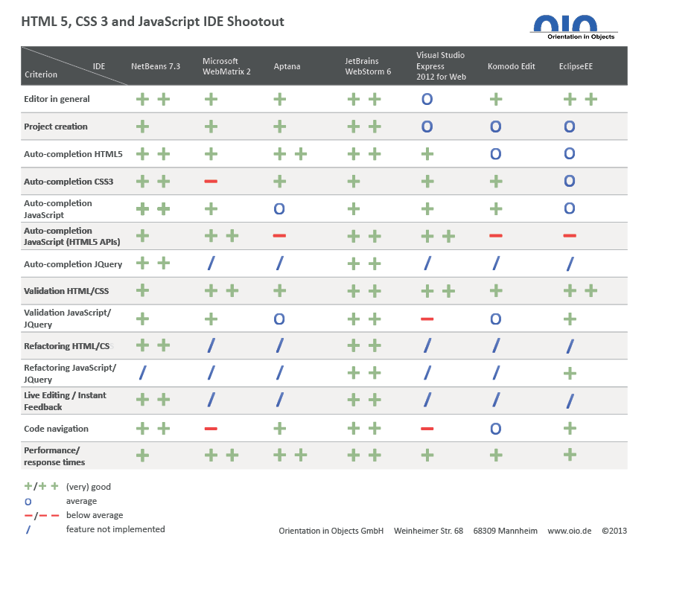

Figure - Comparison of IDEs. Credit: Damm (2013)

In conclusion, Jetbrains Webstorm has been selected as this is the most proficient IDE for JavaScript, HTML, and CSS development. It also has a wide variety of extra features which may be useful as the project progresses (such as Git integration for source control).

* 1. Shared Preferences

Android (2016), state that *“If you have a relatively small collection of key-values that you’d like to save, you should use the SharedPreferences APIs.”.* The SharedPreferences APIs are explained by TutorialsPoint (2016): “Shared Preferences allow you to save and retrieve data in the form of key, value pair.”. The application developed will require the user to log in, using SharedPreferences it will store and access the data across multiple sessions – even when the application has been stopped. The first time the user opens the patient application they will be asked for personal details such as name and home address. In the carer application, they will be required to enter their name and the patient’s app code (this will be used to pair the carer and patient). All of these details will be stored as key-value pairs in SharedPreferences.

* 1. Legal, Social, Ethical & Professional Issues

The main issue involved with the development of these applications is the Data Protection Act 1998. Gov.uk (2016), explain that this law requires any data stored by an application to be *“used fairly and lawfully”, “kept safe and secure”,* and *“kept for no longer than is absolutely necessary”.* The data used by these applications is particularly sensitive as it will contain the location of people who may be mentally ill. To adhere to this law, a privacy policy must be included which explains to users how their data will be used, there will also be an option to delete the user’s account details from the database. To keep the user’s data secure, parameterised queries will be used to protect the database from SQL injection (W3Schools.com, 2016).

Another law the application must comply with is the Equality Act 2010. Gov.uk (2016), explain that *“If you exclude anyone from using your service based on disability, you may be in breach of the Equality Act 2010.”*. Therefore, the applications must meet all usability guidelines such as using a colour scheme which is suitable for colour-blind users.

This project encounters many social issues such as easing the pressure which is put on carers to keep their patients safe. The finished application will enable carers to remotely track their patient. A similar issue is that family members may worry about the location of their family member who suffers from Dementia so they will be capable of tracking them too. This should also reduce the risk of mortality from people with Dementia wandering.

It would be unethical to allow people with Dementia to be tracked without their consent. Therefore, it will be explained within the app that the carer must gain their patient’s consent if they are to use the app. If data such as the patient’s tracking number is released then they could be located by anyone – therefore this must be kept secure to only allow authorised users to locate them.

The Alzheimer’s Society (2014), states that the average annual cost of a person with dementia is £32,250, and that two thirds of this must be paid for by people with Dementia and their families. The most similar app in the product comparison chapter would cost the carer and patient to use on a permanent basis – only allowing a very limited amount of tracking per day. Therefore, the entire application will be free to use to avoid incurring any additional costs to the users.

Software bugs can, depending on their severity, make the software unusable. According to WebMD, the median age of a Dementia sufferer is 83 years old – meaning it’s quite likely that they do not have much experience with using technology. Therefore, the apps should be entirely bug-free and easy to use.

1. Design Specification

The requirements stated below were elicited using the literature review and product comparison. Unfortunately, ethical approval was impossible to obtain to contact people with Dementia in order to complete surveys, JAD workshops, and get feedback from prototypes. The requirements have been prioritised using a MoSCoW (Must, Should, Could, Would have) analysis to determine which features would create the Minimum Viable Product (MVP).

* 1. Non-functional Requirements

|  |  |  |
| --- | --- | --- |
| **No.** | **Requirement** | **MoSCoW** |
| 1 | The system’s database must not be vulnerable to SQL injection | Must |
| 2 | The applications must provide a privacy policy | Must |
| 3 | The systems must use a clear font and colour scheme to ensure the visually impaired are not at any disadvantage | Must |
| 4 | The patient system must request the user’s consent to track them | Must |
| 5 | The systems should be able to handle errors (such as one device failing) and continue to operate - albeit at a reduced functionality | Should |
| 6 | The systems should be fully tested | Should |
| 7 | The systems should have de-coupled, cohesive code to allow for easy improvements in the future | Should |
| 8 | The system could perform well (provided there is time in this project), providing the user with their patient’s location or their route home without unreasonable delay | Could |
| 9 | The systems would be ported to iOS if there was more time as will be developed on the hybrid platform ‘Ionic’. This port should have no more or less functionality than its Android counterpart and should work across platforms (i.e. Carer on iOS and patient on Android) | Would |

* 1. Functional Requirements

|  |  |  |
| --- | --- | --- |
| **No.** | **Requirement** | **MoSCoW** |
| 1 | The carer system must allow the carer to remotely view the most recently accessed location of their patient | Must |
| 2 | The patient system must allow the user to access navigation to their home with Google Maps through a simple user interface | Must |
| 3 | The systems must ensure that the users enter their details on the first use, and that these details are not requested in subsequent uses | Must |
| 4 | The carer system must allow the user to track a patient using their uniquely generated code. | Must |
| 5 | The systems should have a tutorial page which explains how to use the apps. | Should |
| 6 | The carer system should allow the carer to track more than one patient | Should |
| 7 | The systems should allow the user to change their password | Should |
| 8 | The systems should allow the user to change their username | Should |
| 9 | The systems should allow the carer to change the patient’s home address (this is more secure than allowing the patient to change their own address) | Should |
| 10 | The systems could offer information about Dementia - particularly topics discussed in the literature review such as dangers, preventative measures, and treatments | Could |
| 11 | The systems could allow the users to log in with alternative methods such as Facebook and Google | Could |
| 12 | The system could notify the carer when the patient has requested navigation home | Could |
| 13 | The patient system would have a medication reminder if there was more time to develop it | Would |
| 14 | The patient system would analyse the user’s actions to determine how often they get lost, and attempt to discover patterns. These would be retrievable from the carer app. | Would |
| 15 | The patient’s app would include the option for Music Therapy to attempt to improve their memory if there was more time to research the topic and incorporate it into the app. | Would |

* 1. MVP

From these requirements, the Minimum Viable Product (MVP) can be determined to be two applications - one for the carer and one for the patient. The carer’s application must allow the carer to sign in, add a patient using the patient’s code and track the current location of the patient. The patient’s application must allow the patient to sign in and navigate home (using Google Maps) via a simple UI. Both applications must contain a privacy policy, must be accessible for the visually impaired and must protect the database from SQL injection attacks when connecting to it.

* 1. UML Diagrams

Below are the UML diagrams which have been created to aid in the programmatic design of the system.

* 1. Class Diagrams

The Class diagrams below demonstrate all the classes which the apps will be comprised of. They also show which attributes each class will have and all the functions which will be within the class.

* + 1. 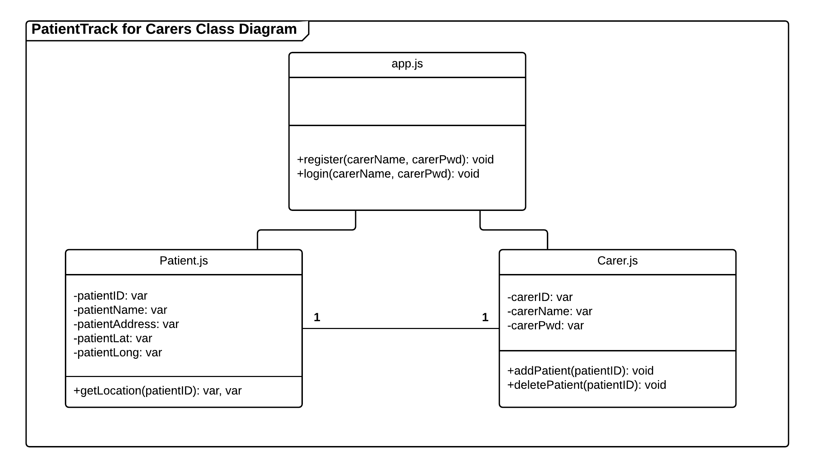 PatientTrack for Carers

Figure - PatientTrack for Carers Class Diagram

* + 1. 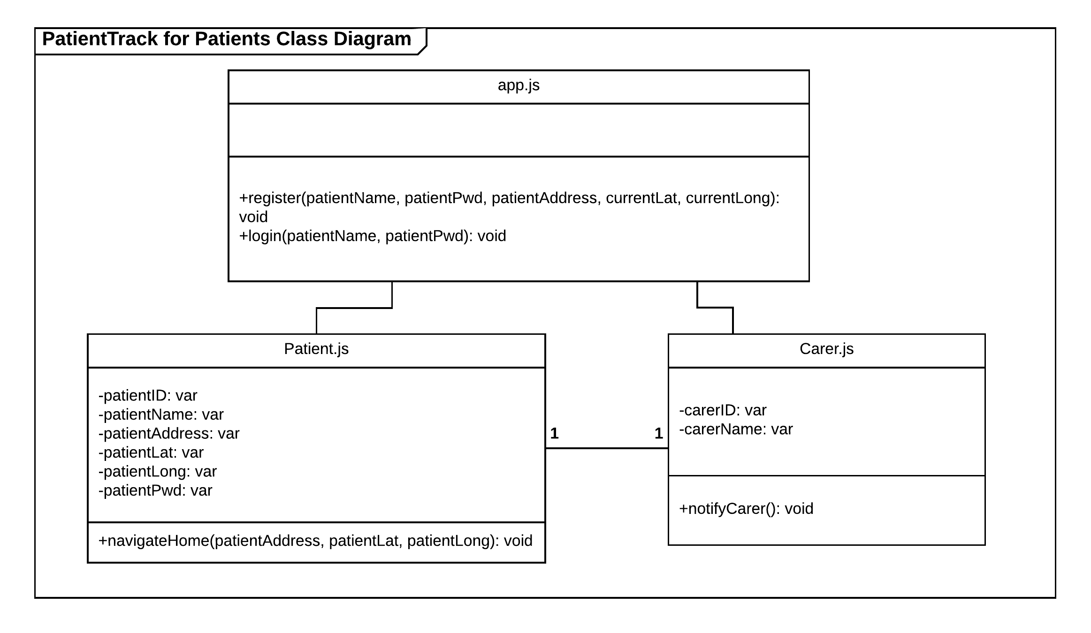 PatientTrack for Patients

Figure - PatientTrack Class Diagram

* 1. ERDs

Entity Relationship Diagrams (ERDs) show each entity that will be created within the Database for this system.

* + 1. Conceptual ERD

The conceptual ERD is the most high-level diagram. This only shows which tables will be created, their primary keys and the relationship between tables. This stage is most useful for determining which entities will be required in the system, and can be easily altered if something has been missed.

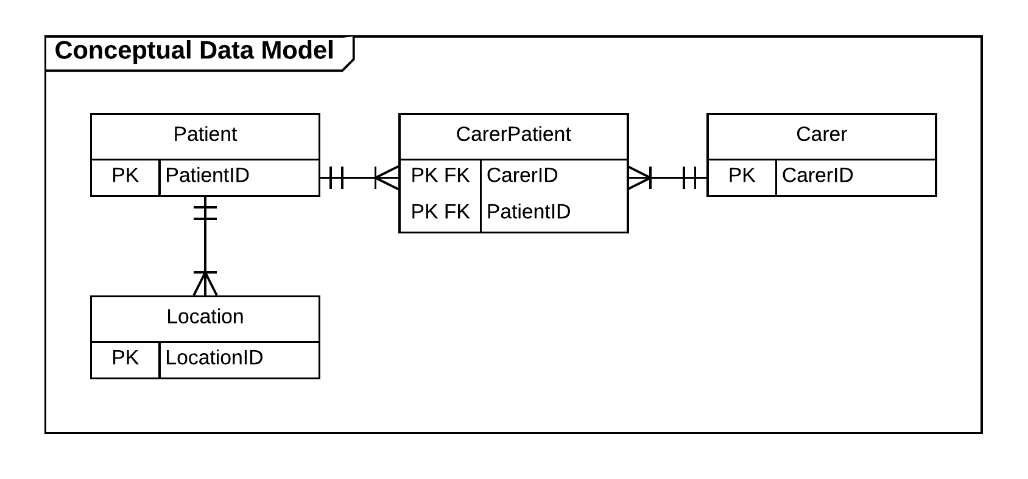

Figure - Conceptual Data Model

* + 1. Logical ERD

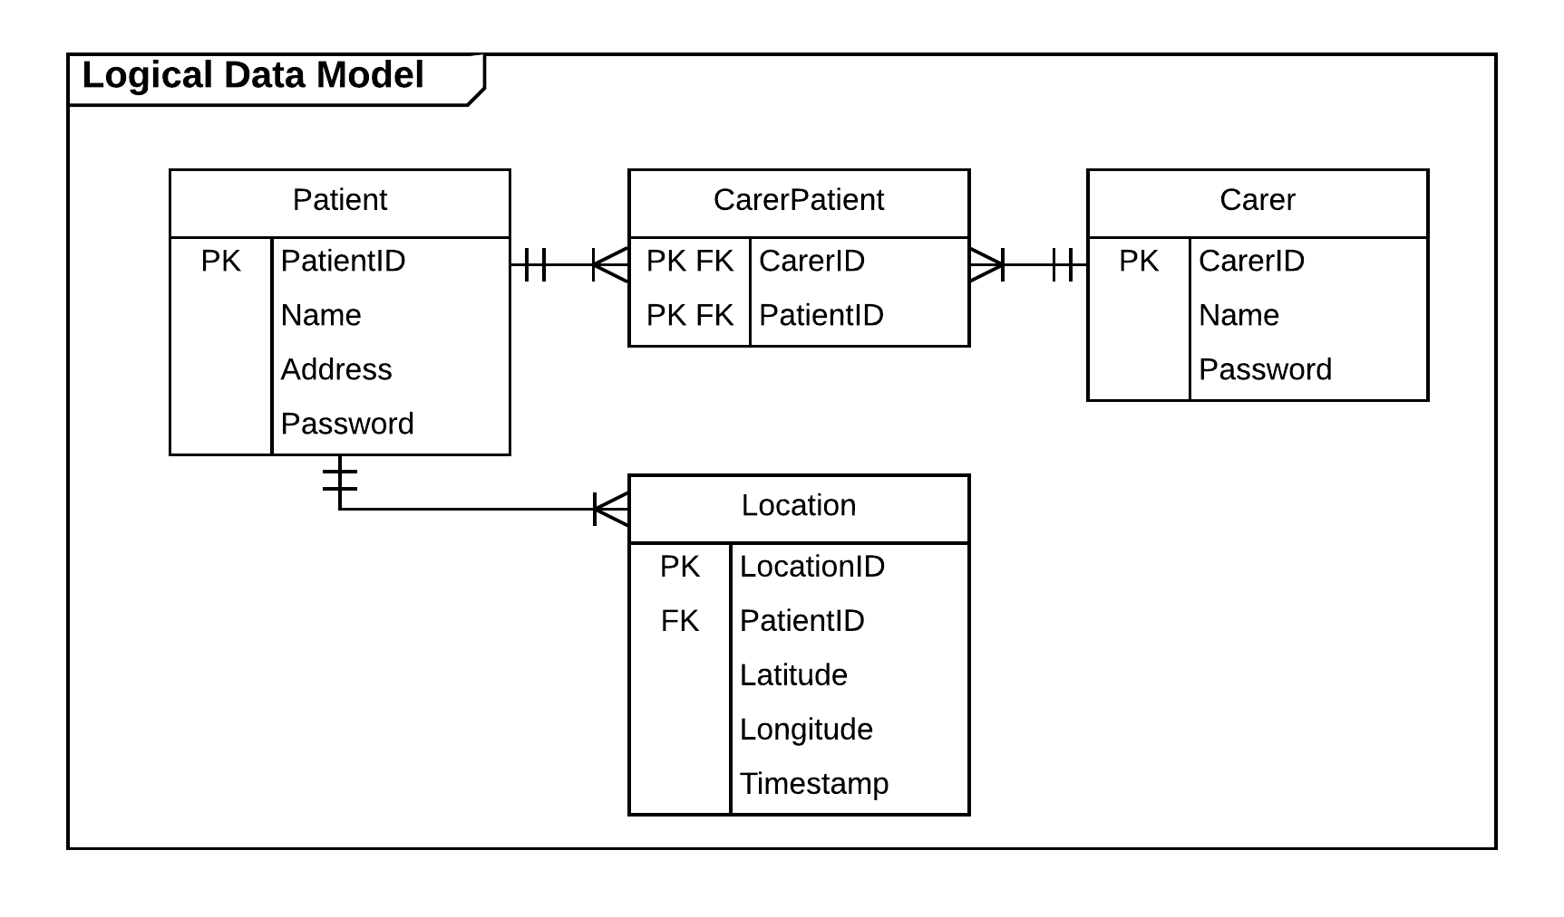The logical ERD contains more information that the Conceptual. This diagram shows all the attributes of each entity, including any foreign keys. At this stage alteration is still possible, however any alterations will require the conceptual ERD to be updated.

Figure - Logical Data Model

* + 1. Physical ERD

The physical ERD is the most details ERD. This shows the data types which each attribute will be stored as - this will reduce the risk of errors occurring within the system. At this stage, no alteration should be necessary, and any required changes may be time consuming.

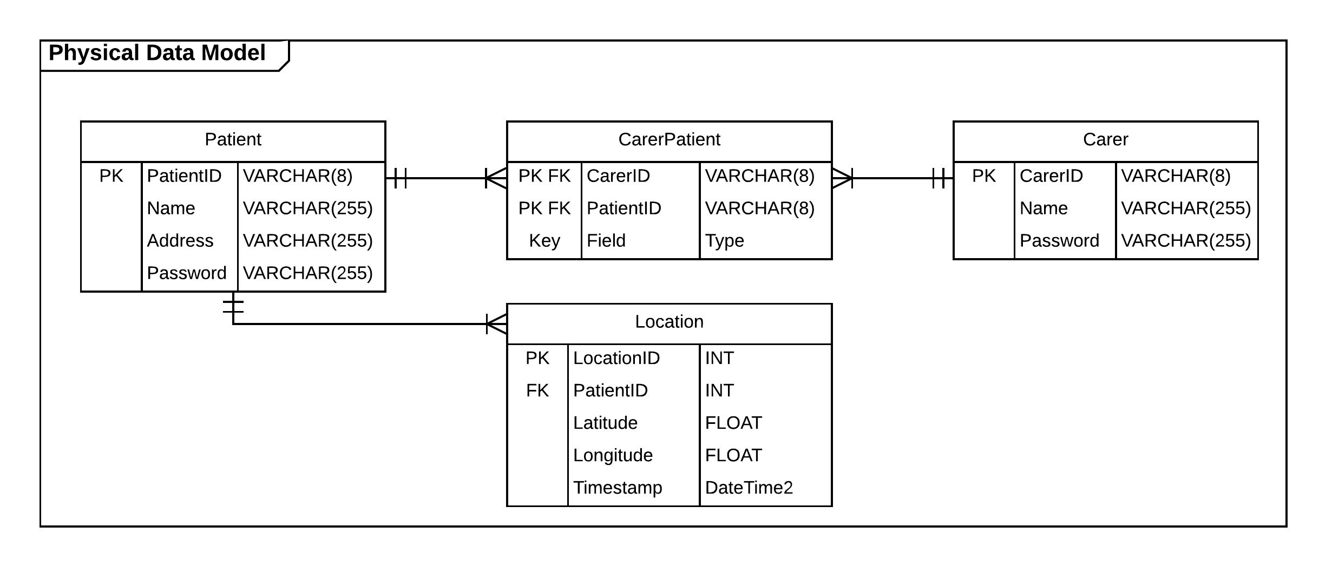

Figure - Physical Data Model

* 1. Sequence Diagrams

Sequence diagrams show how entities interact with each other when the system is running.

* + 1. PatientTrack for Carer - Adding new patient

This diagram depicts how the Carer would use the app to log in and enable them to track one of their patients.

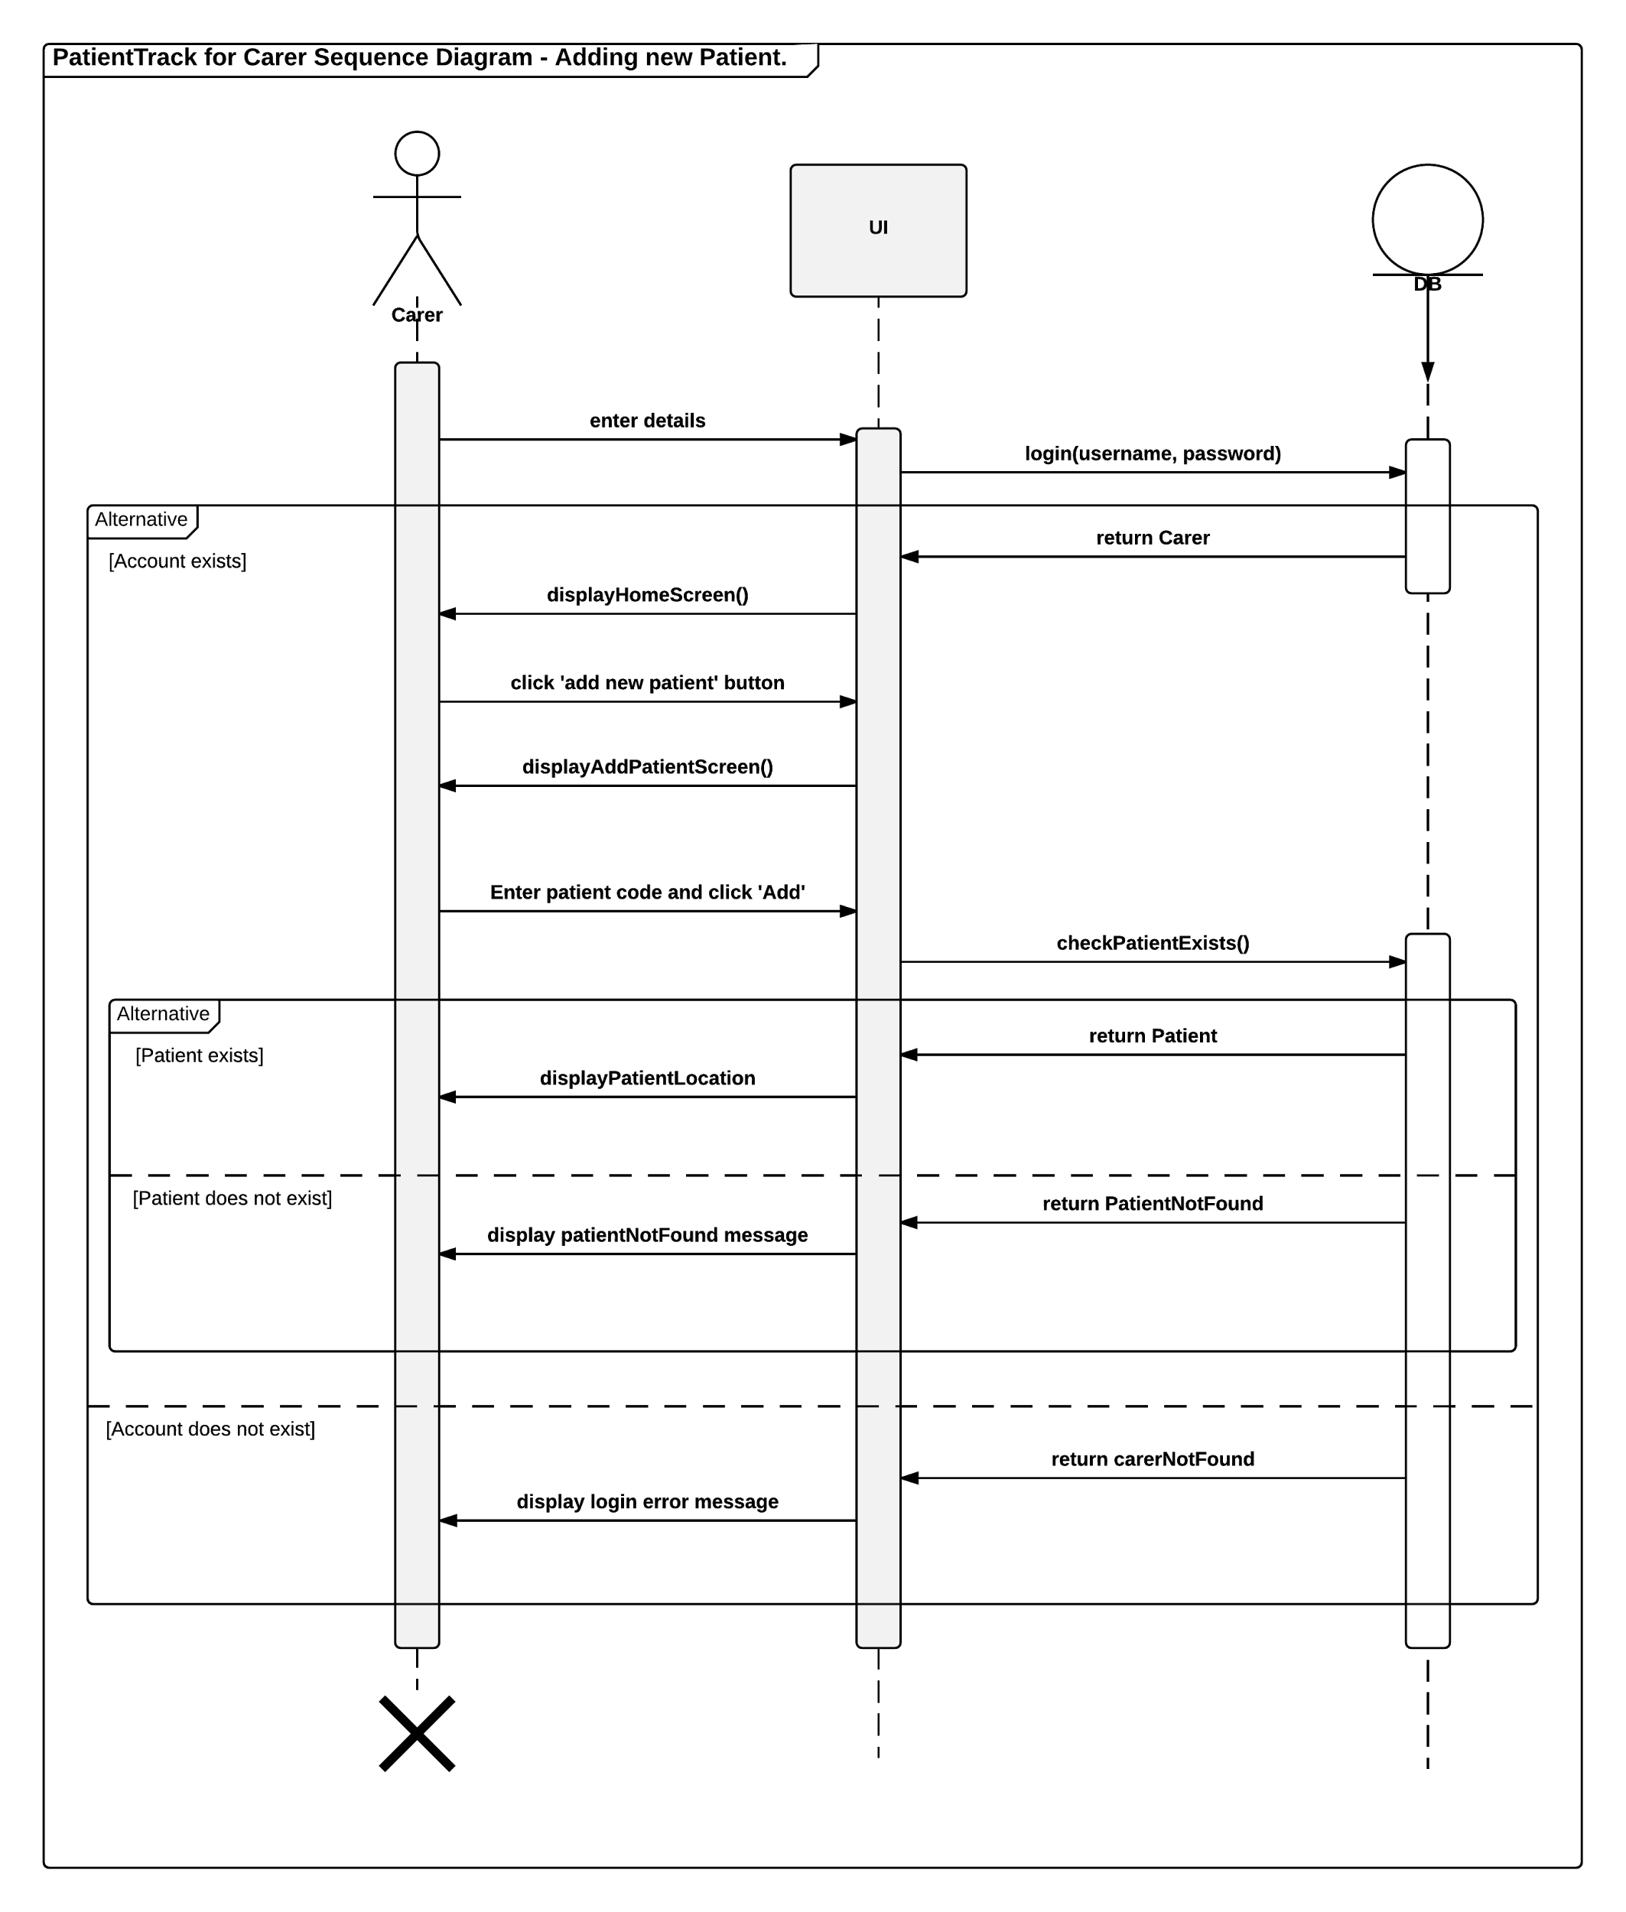

Figure - Add Patient Sequence Diagram

* + 1. PatientTrack for Patient - Clicking lost button

The sequence diagram below demonstrates the entity interactions involved in a patient clicking on the lost button. The button opens Google Maps navigation from their location to their home location.

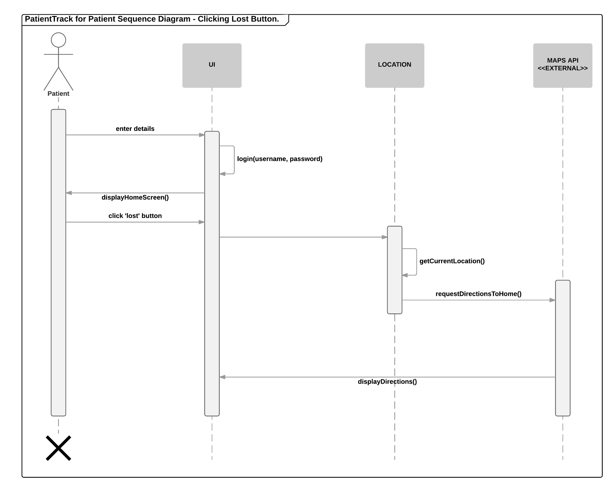

Figure - Patient Lost Sequence Diagram

* 1. Use Case Diagrams

Use Case diagrams are used to display everything that the system will be used to do, and who will be using it.

* + 1. 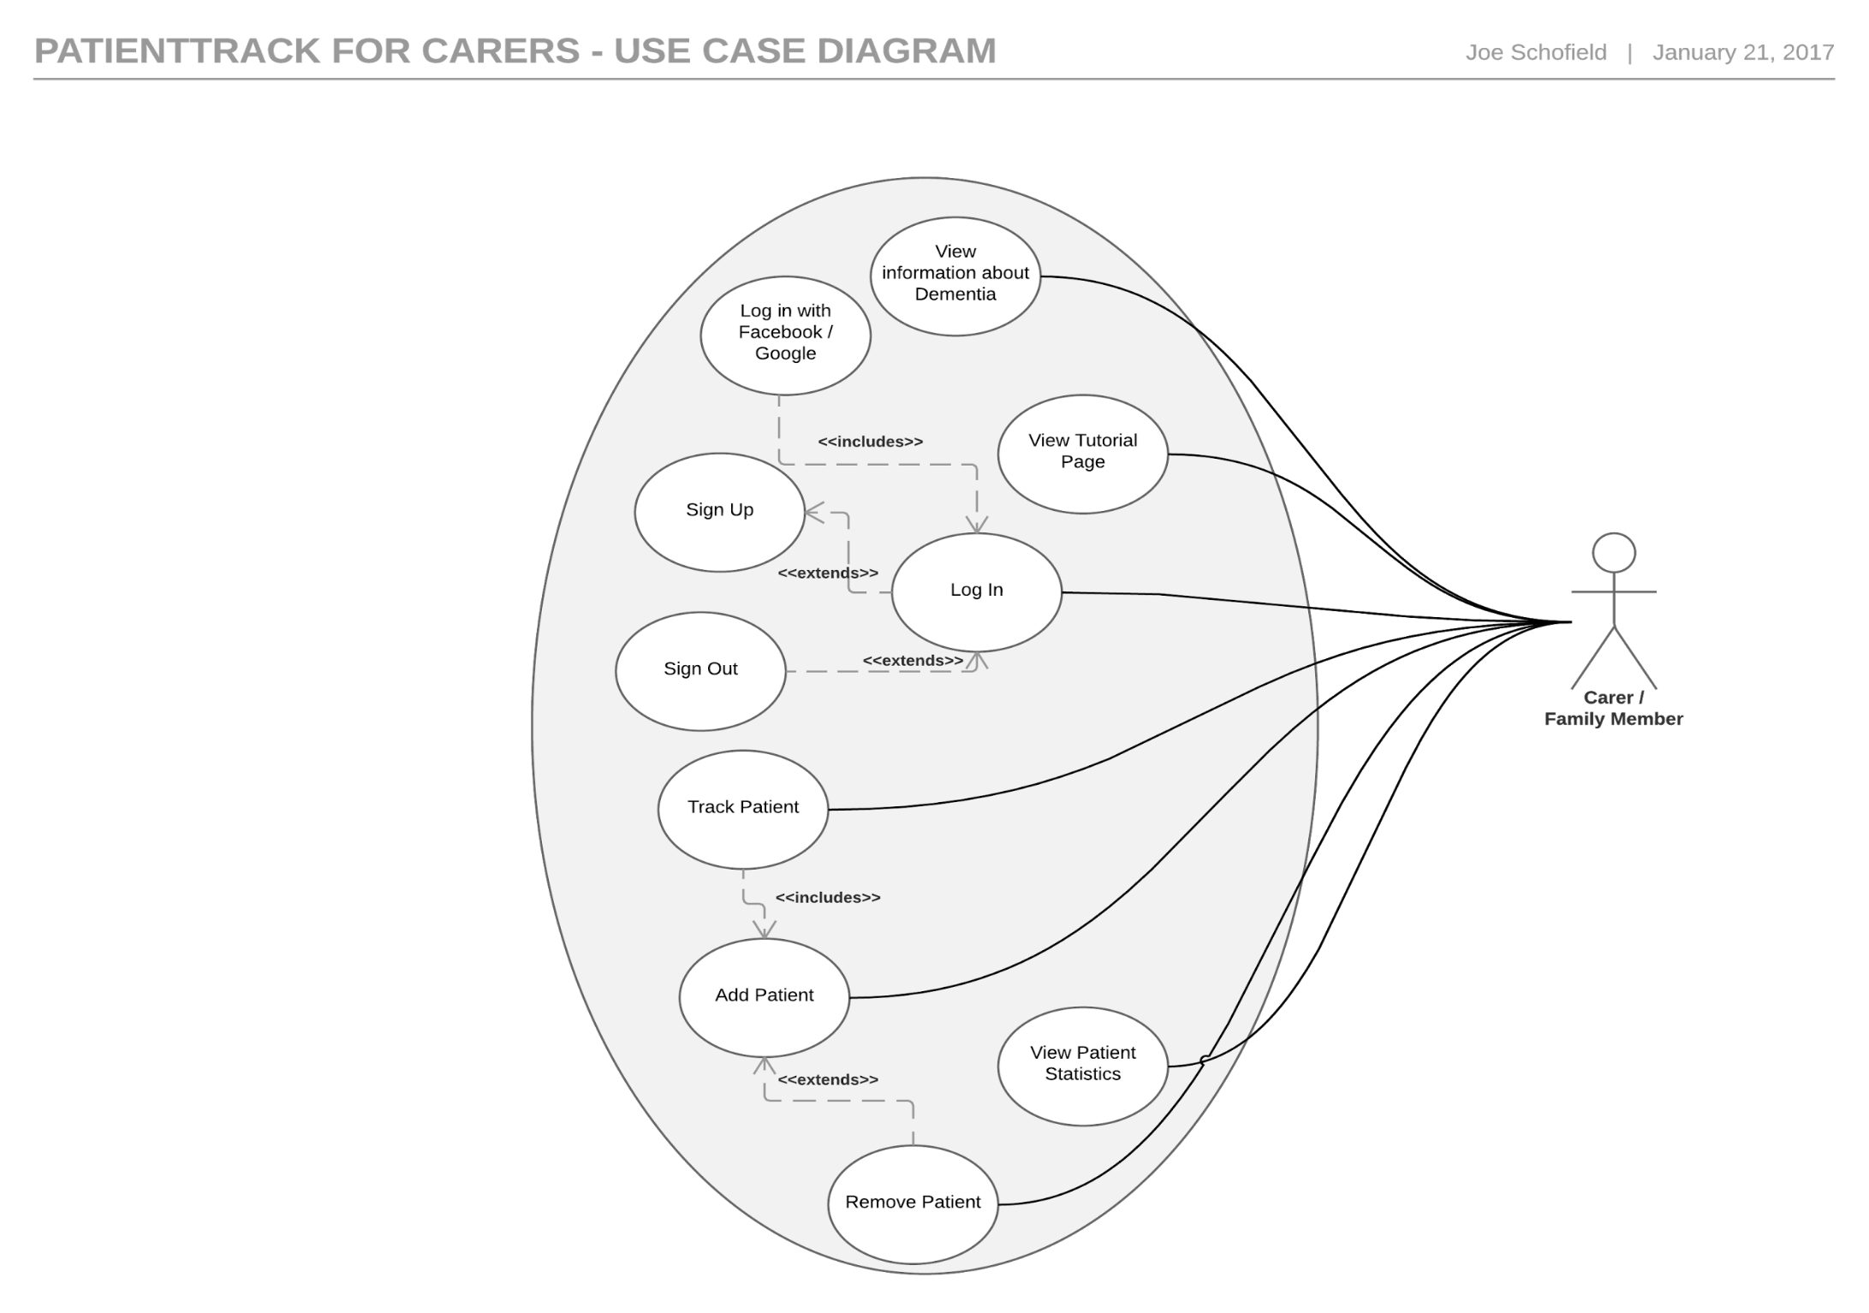 PatientTrack for Carers

Figure - PatientTrack for Carers Use Case

* + 1. 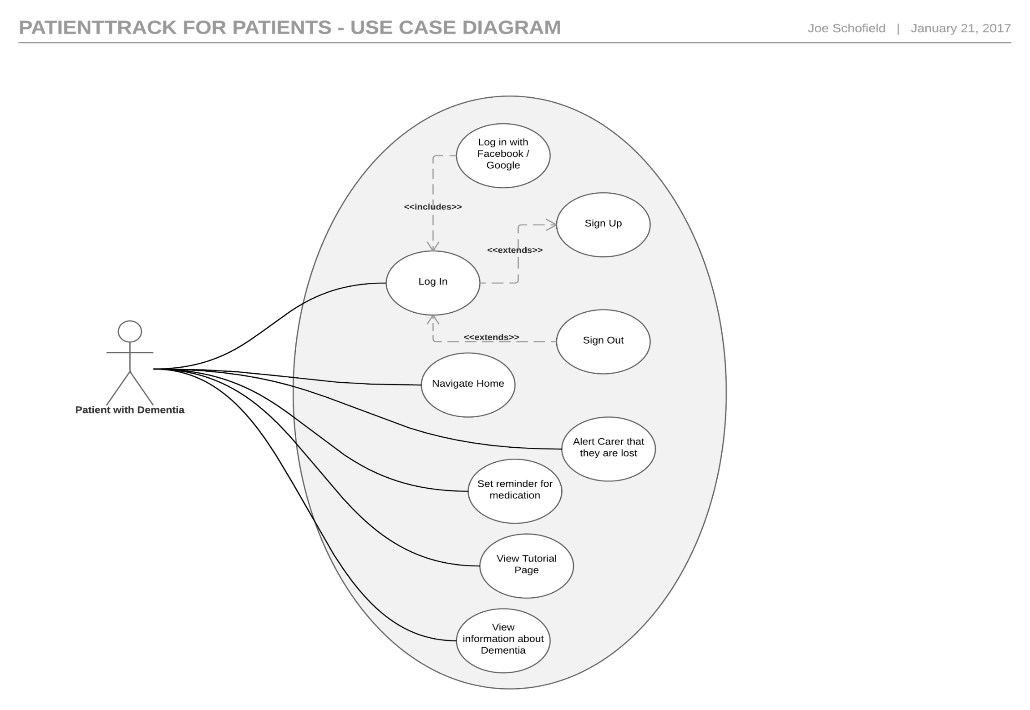 PatientTrack for Patients

Figure - PatientTrack Use Case

* 1. Deployment Diagrams

The deployment diagram shows the physical locations on which the system will be run.

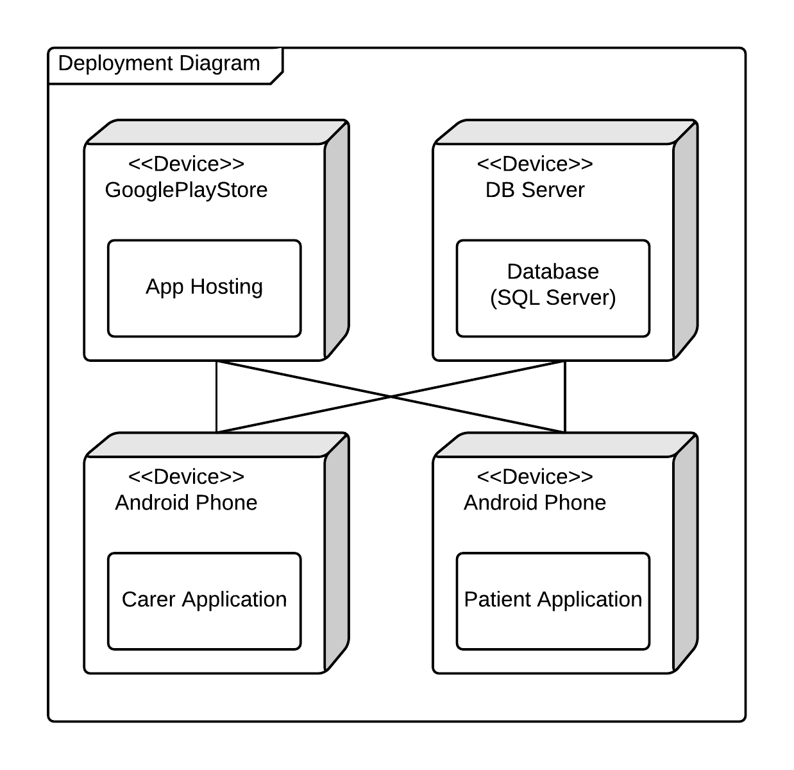

Figure - Deployment Diagram

* 1. State Machine Diagrams

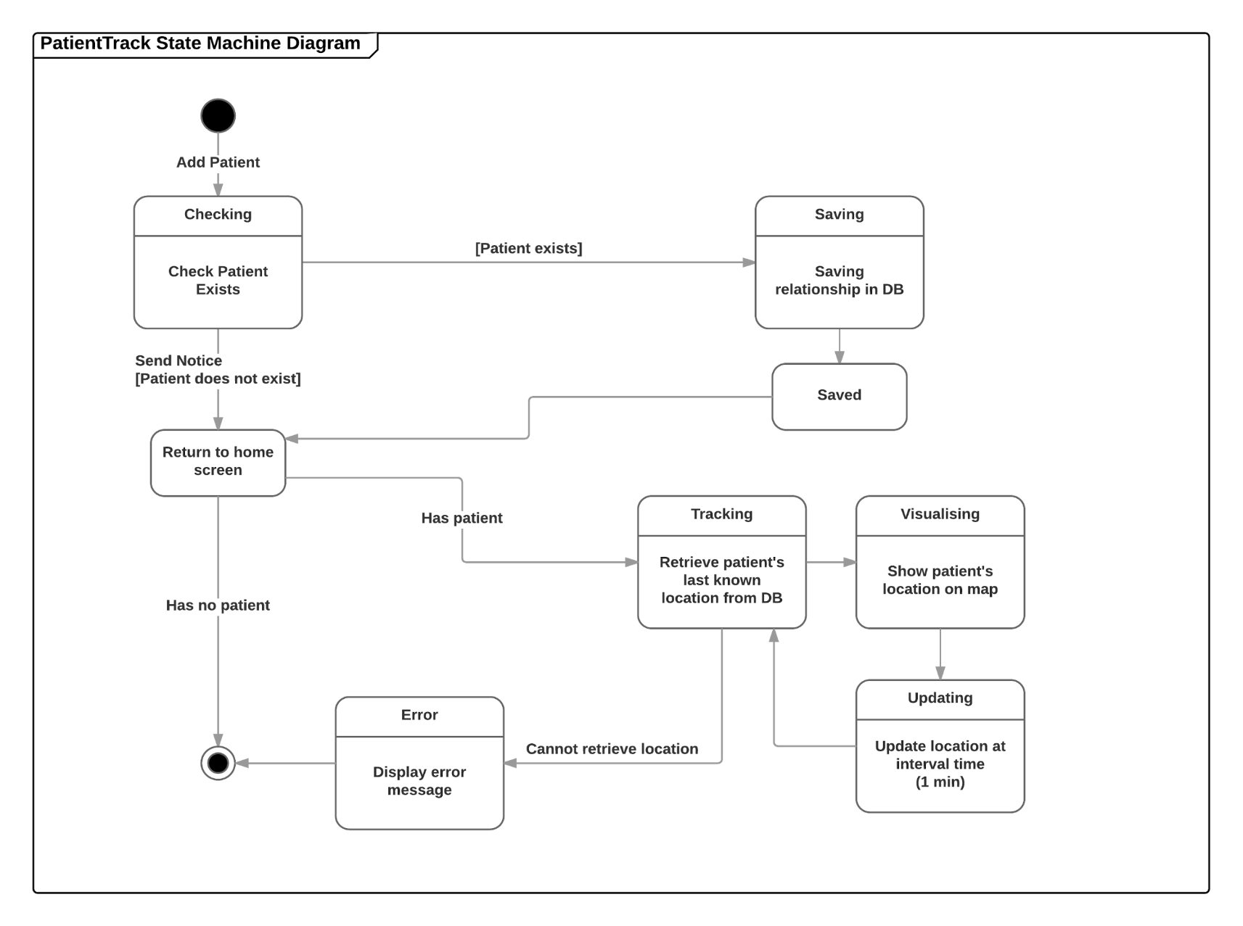The state machine diagram shows the state of the system throughout a particular process. This diagram models the system state during the process of adding and tracking a patient.

Figure - State Machine Diagram

1. User Interface Design

In this section, several tools have been used to design the user interface of the PatientTrack applications.

* 1. Wireframe Low-Fidelity Prototypes
     1. Carer App 1

|  |  |
| --- | --- |
| This is the register / sign in page of the Carer app. The user will only be shown this the first time they open the app as after they have logged the username & password will be stored in SharedPreferences. | Prototype I.png  Figure |
| This is the home screen of the app. It shows the details of the carer’s patient including last known location. If they have not registered their patient it will show an option to add a patient. | Prototype I.png  Figure |
| This is the add patient page of the carer app. The patient’s app will generate a code which, when entered in the carer app, will enable the carer to obtain the location of the patient. | Prototype I.png  Figure |

* + 1. Carer App 2

|  |  |
| --- | --- |
| This is an alternative login screen - all that is initially required from the carer is the name. The issue with not using a password is that if the carer signs out of the system then they would have to create a new account to sign back in. | Carer Prototype II.1.png  Figure |
| This is the patient tracking page, this is identical to the first prototype. However, this prototype allows the carer to have more than one patient, as can be seen in the next page. | Prototype II.png  Figure |
| This page shows all the patients that the carer has added, with the option to edit, delete and add new patients. Clicking on the patient would take the carer to the tracking page. | Prototype II.png  Figure |

* + 1. Patient App 1

|  |  |
| --- | --- |
| This is the login page for the patient app. When the patient signs up they will be required to accept the terms and conditions as their data will be stored remotely. | Prototype I.png  Figure |
| This is the main page for the Patient’s app. It is intentionally very minimalistic as to avoid confusion. The circle will be a button which will take the user to a Google Maps navigation page of their route home (address will be stored within the app). | Prototype I.png  Figure |
| This is the settings page of the app. For the MVP, the only setting which may change is the patient’s address. | Prototype I.png  Figure |

* + 1. Patient App 2

|  |  |
| --- | --- |
| As the login details will be stored in shared preferences it is unlikely that the patient will be signing in – more likely that they will be registering. Therefore, it may be more suitable to show a register page with a link to a sign in page. | Prototype II.png  Figure |
| This is the main page for the patient app. It incorporates the setting of address into one page to avoid too many pages within the app. The disadvantage of this approach is that the patient may accidentally change the address to something incorrect. | Prototype II.png  Figure |

* 1. Feedback

Demonstrating the wireframe prototypes to a colleague has given them a chance to offer their opinion on which style is preferable and any issues that they can see arising.

The colleague suggested that having the option to add more than one patient is ideal as – while most Dementia care is done on a one-to-one basis – some carers may have more than one patient. They also stated that having all the register and login features on one page is the better option as this is more conventional so will cause the least confusion.

On the subject of setting the patient’s address, they stated that this is best done on a separate screen to avoid accidentally changing the address to an incorrect location – and that the option to change the address of a patient may be best to include on the carer’s app so that the carer can monitor where the patient will be navigating to.

The colleague really liked the large ‘Take me home’ button on the patient’s app as this, they felt, is a very clear way of using the app. One issue that the colleague said the users may encounter is that if they are on a slow phone – or a phone without Google Maps – then they will struggle (or not be able to use at all) the navigational functions of the app. However, most mobile phones at present have the ability to navigate using Google Maps without issue as all Android phones have Google Maps stored on the phone automatically, so this should not be a problem.

* 1. Colour Scheme and Font Selection

Google (2017), have created comprehensive instructions for using Android design, known as “Material” design. IonicMaterial (2017), have provided examples and open-source CSS code which can be applied to any Ionic app. This will be incorporated into the app to apply styles in keeping with the Google’s material guidelines in order to create a familiar UI for the user.

For the colour scheme, I have used colours which are associated with healthcare. According to NHS (2017), people *“strongly associate the NHS with the colours blue and white”*. Therefore, these will be used alongside a light green – another colour strongly associated with healthcare. I will use the preset colours provided with the Ionic Bootstrap CSS as these are easily accessible and work well together. The blue I will use is named ‘calm’, and the green is named ‘balanced’. The table below displays the hex codes for these colours.

|  |  |  |
| --- | --- | --- |
| **White** | **Blue** | **Green** |
| #FFFFFF | #11C1F3 | #33CD5F |

For the font, a font developed by Google has been selected. This is a font which is used in many Android applications in addition to Google Chrome. ‘Roboto’ is a sans-serif typeface which is easily readable and is considered to be a friendly font. Ionic’s CSS automatically sets the font to Roboto.

|  |  |
| --- | --- |
| **Style** | **Example** |
| Regular  *Italics*  **Bold** | Roboto Font  *Roboto Font*  **Roboto Font** |

* 1. High Fidelity Prototype

The low-fidelity prototypes have been developed further, applying changes from the feedback given, in order to create a high-fidelity prototype. These were developed this using Axure – the full prototypes are available at the following web addresses:

* Carer app: https://n34orf.axshare.com/#g=1&p=sign_in
* Patient app: https://c4mej5.axshare.com/#g=1&p=sign_in
  + 1. Carer App

|  |  |
| --- | --- |
| **Description** | **Image** |
| This is the first page the user will be shown when they open the app. As it is likely that the user will not need to sign out they are shown the registration page initially. There is a link to the sign in page if they already have an account. | Figure |
| This is the sign in page. If the user already has an account, then they can log in here. There is also a link to the registration page if they do not have an account already. | Figure |
| This is the home page of the carer app. The carer is shown a list of all the patients they have registered. They can click on the patient’s name to be shown their location. They can also remove patients they have added and add new patients. | Figure |
| This is the view for adding a new patient. The carer enters the code displayed in the patient’s app and their details will be shown on the home page. | Figure |
| This is the locate patient page. The carer is shown a map with the patient’s location pinpointed. | Figure |

* + 1. Patient App

|  |  |
| --- | --- |
| **Description** | **Image** |
| This is the registration page for the patient. It requires their username, email address, home address and password. If the user already has an account, then they can click the ‘Sign in’ button. | Figure |
| This is the sign in page. It takes the user’s username or email address, and password. | Figure |
| This is the homepage for the patient app. The patient can click the home button and will be taken to Google Maps navigation. | Figure |
| The is an example of Google Maps navigation. This will be done within the Google Maps app. | Figure |
| This is the settings page. From here the patient can change their address, sign out, and see their patient code to give the carer. | Figure |

1. Implementation

This section contains information regarding the implementation of the patient and carer applications. The applications were implemented using the Ionic framework, using AngularJS and HTML.

* 1. Development Issues

During development, some issues were encountered which hindered the velocity of production.

The first issue was the discovery that mobile applications should not communicate directly with a database. Therefore, a REST API was designed and developed to enable this connection.

Secondly, the developer had very little experience programming with AngularJS, however this was resolved by following tutorials from W3Schools (W3Schools, 2017), and using examples from the Ionic website (Ionic Framework, 2017).

Another issue was discovered during testing, the unit testing software could not be correctly configured to run on the developer’s laptop. Therefore, the applications had to rely on Black box testing for the applications.

A final issue encountered was that DSDM benefits from direct contact with the client. However, this was impossible due to ethical reasons. To resolve this, colleagues were used as as end users, and were askedto use the app as if they have little or no experience with technology.

* 1. Prototypes

During development, several prototypes were created which were tested once they were complete. These were then further developed to increase the available functionality of the system.

* + 1. Prototype 1

The first prototype for each app had very simple functionality. It was simply an application which could call the API to register a user, and get a user’s details. Initially, a new blank Ionic project was created. From this, the UI for the login and register pages was designed to make it look like the high-fidelity prototypes. The API call was quite simple, as Angular has an http function built in which can create the calls, and return the data. One issue discovered was that data could not be accessed across different controllers (each page uses a different controller) using the $scope variable, so that when the user navigates to a different page, their data is no longer accessible. To work around this, the user’s data was stored as an object within the $rootScope variable, rather than the $scope variable, as this is accessible anywhere.

* + 1. Prototype 2

The second prototypes, built on top of the first, had the main focus of creating a connection between the carer and patient. To do this the API was altered to enable a call which requires the patient’s unique code as a parameter, and updates the CarerPatient table in the database to create that connection. Then, the code to display a list of all patients connected to the carer in the carer app was added, in addition to a popup box which queries the API’s new method to connect a carer and patient. Then, in the patient’s app, code was added to view the user’s patient code within the app, along with some other details.

* + 1. Prototype 3

The third prototypes were implemented to access the location of the patients. To do this, the Cordova geolocation plugin was used to retrieve the user’s current location. This retrieves two values; the latitude and longitude of the user. Then, the API was altered to create a new method which enables the apps to POST the user’s location to the Location table in the database. This is then queried from within the patient’s application. To access this data, a Google Map element was implemented within the Carer’s app. This is accessible by selecting a patient from the list developed in the second prototype. This map then plots the user’s location, along with the time they were located.

* + 1. Prototype 4

The fourth and final prototypes developed focused on the rest of the functional features such as updating the user’s username and password, altering the patient’s address from the carer app, and deleting connections and accounts. In this prototype, the help and privacy policy pages were also added to meet legal requirements. Finally, CSS styling was added to each of the pages to ensure they look like the high-fidelity prototypes. This prototype met all of the ‘must have’ and ‘should have’ requirements, so was deemed to be complete for this project.

* 1. Differences to Original Design

The agile framework, DSDM, prescribes an iterative process. Therefore, the implemented systems differ from the original designs. While the UI is mostly identical to the prototypes, the designed code-behind has changed vastly from the designs, mostly due to the developer’s inexperience with AngularJS programming practises. An API was required to enable the apps to communicate with the Database (it is more secure than calling the database directly from the app), and so had to be developed. The differences are displayed in the following diagrams.

* + 1. Updated Physical Data Model

The Database model altered slightly during development. This was because it was decided that for all users to be unique, the users should register using their email address. The patient table also required an additional column for the PatientCode, using which the Carer can connect with the patient.

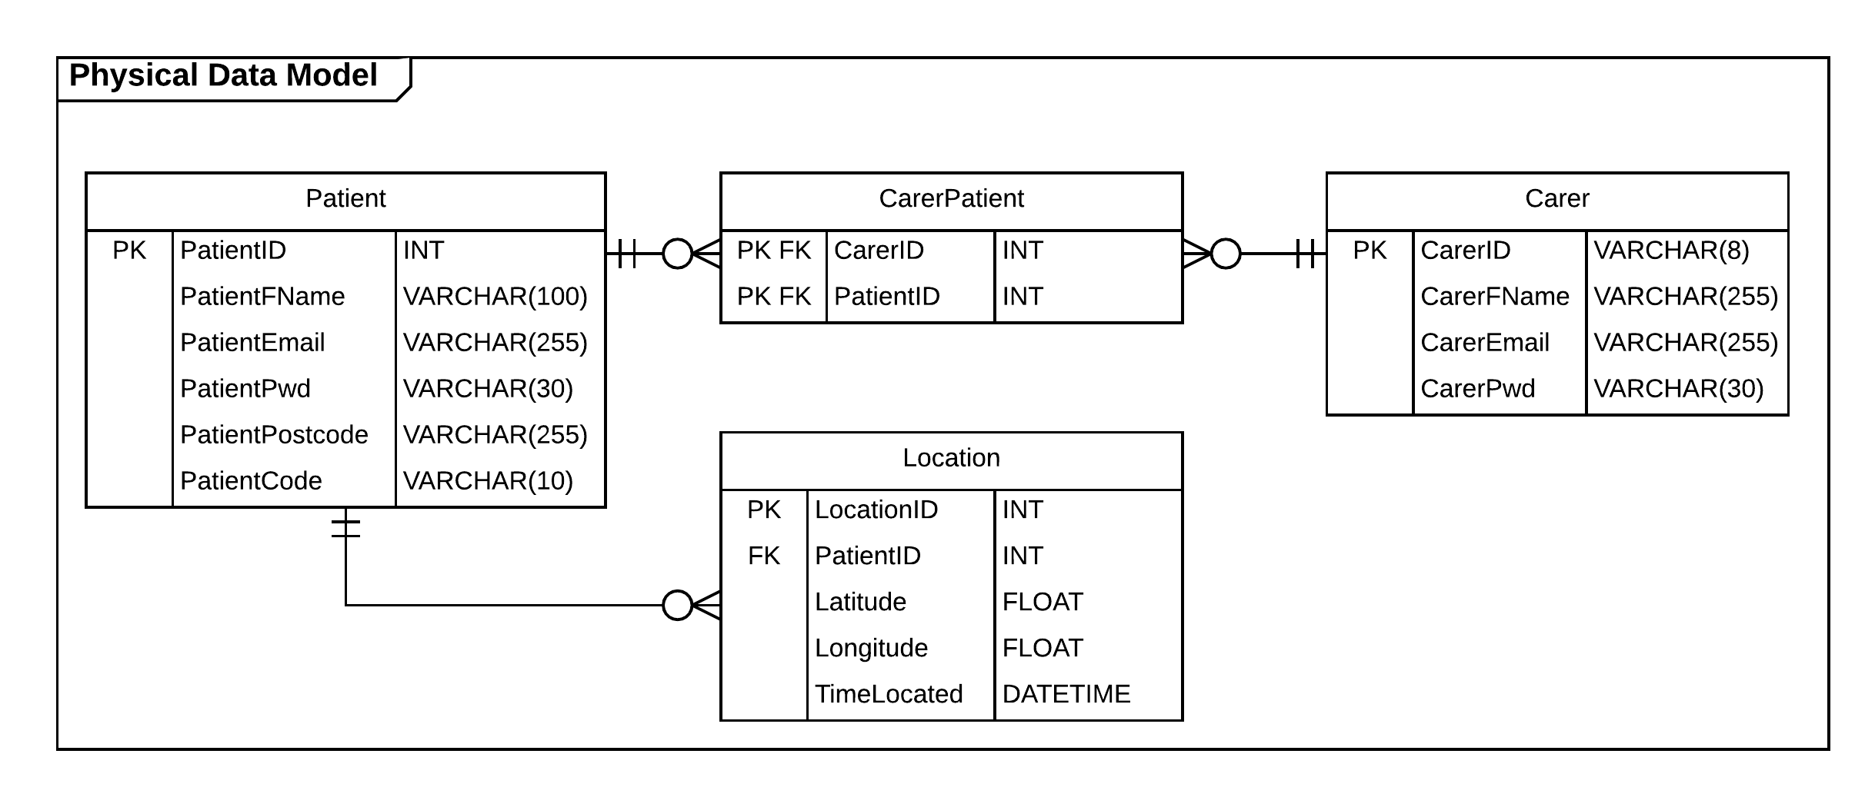

Figure - Updated Physical Data Model

* + 1. Updated PatientTrack for Carers Class Diagram

As mobile apps should not communicate directly with a database, an API was created which can be queried by the apps to connect them to the database. Another difference is that controllers were used to handle event on each page within the app.

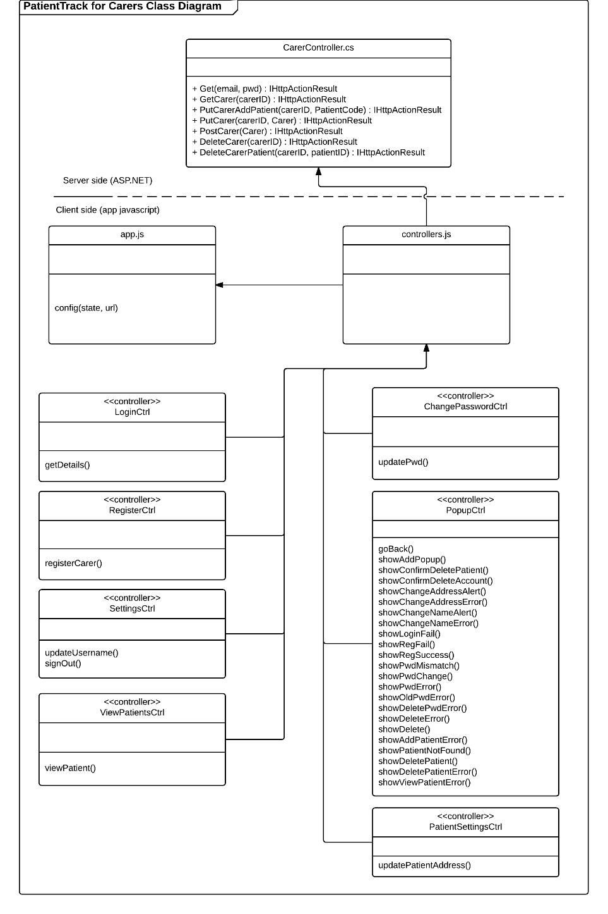

Figure - Updated Carer Class Diagram

* + 1. Updated PatientTrack for Patients Class Diagram

Like the changes to the Carer app, the Patient app calls the API instead of querying the database directly. This app also makes use of controllers.

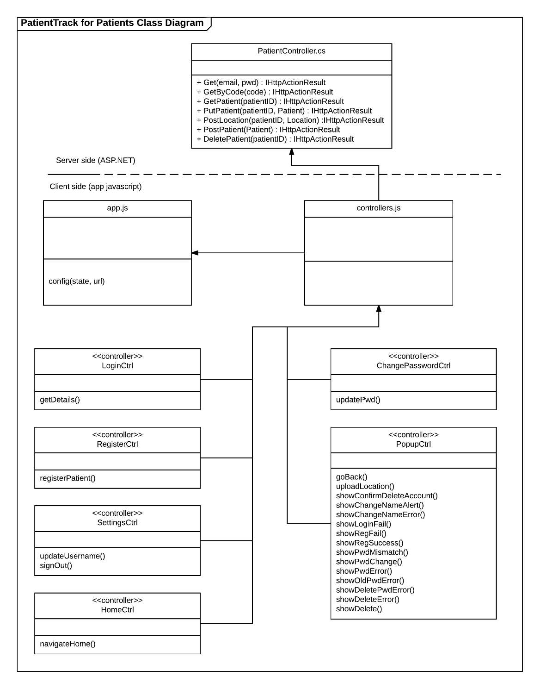

Figure - Updated Patient's Class Diagram

* + 1. Updated Deployment Diagram

As the apps have not been published, they are not stored on the Google Play Store’s servers. Another change is that the API is stored on the same server (hosted on MS Azure) as the database – this ensures that the calls to the API can access the Database much faster.

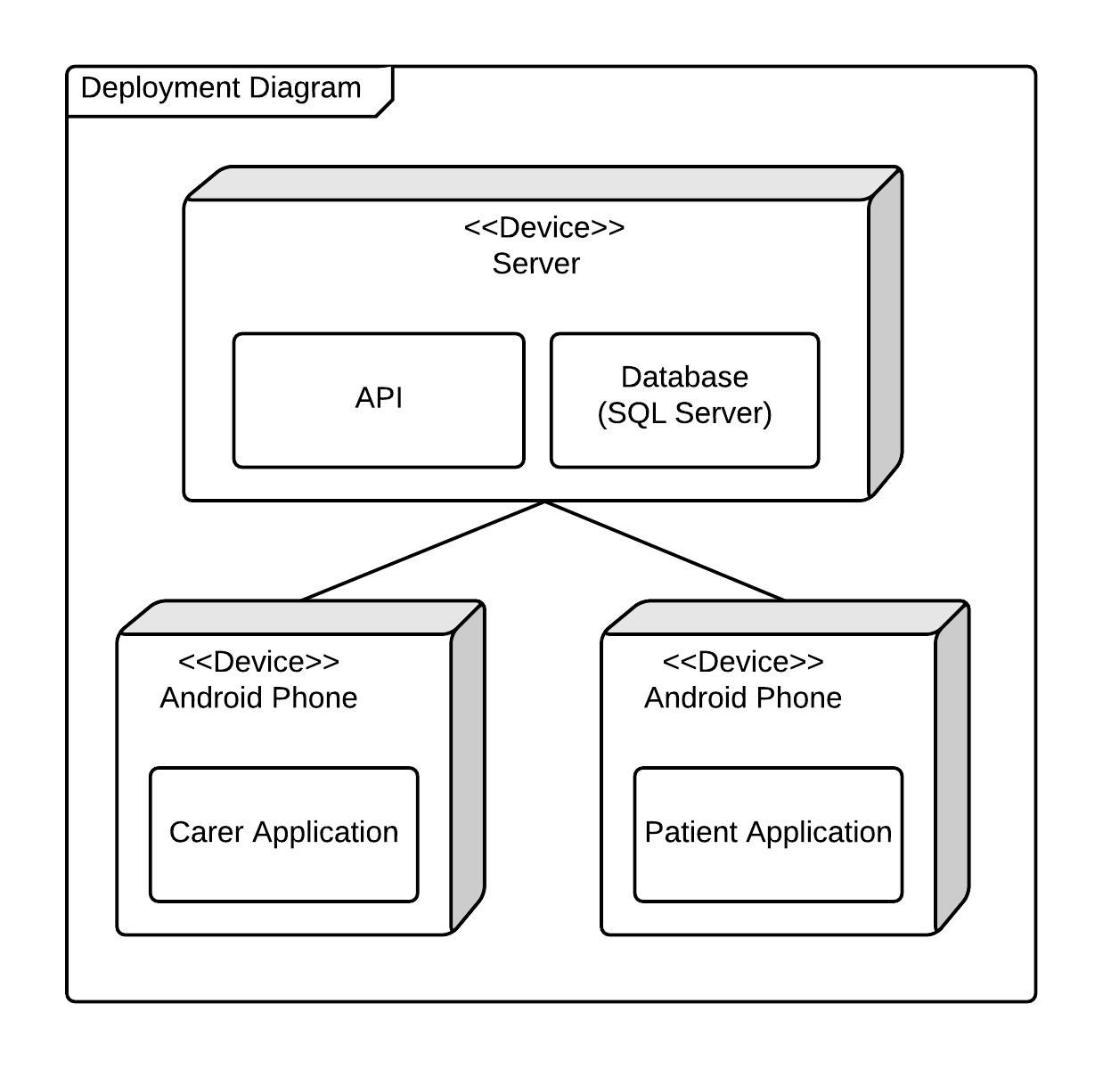

Figure - Updated Deployment Diagram

* 1. Functionality

To effectively evaluate the functionality of apps, appendix B.2 contains a demonstration of how each of the functional requirements has been fulfilled. In addition to this, appendix A shows the full system’s functionality, with screenshots.

* 1. Implementation from Designs

The prototypes created as part of the design stage were incredibly useful in designing the applications. Using these ensured that all functionality could be met, adding features where necessary (such as a link to the change password page). The HTML required for these pages was reasonable simple, as the Ionic Framework has many of its own CSS classes, which can be used to create complex objects on the page.

* 1. Interim Testing

During development, as each prototype was finished, the system was presented to colleagues to test features developed in that iteration. From this, valuable feedback on the apps was received – spanning areas such as error handling, user interface, and performance.

One colleague’s feedback stated that the error message for a failed registration was too vague. From this, a list of possible reasons as to why the registration may have failed was added to the popup. (Figure 38).

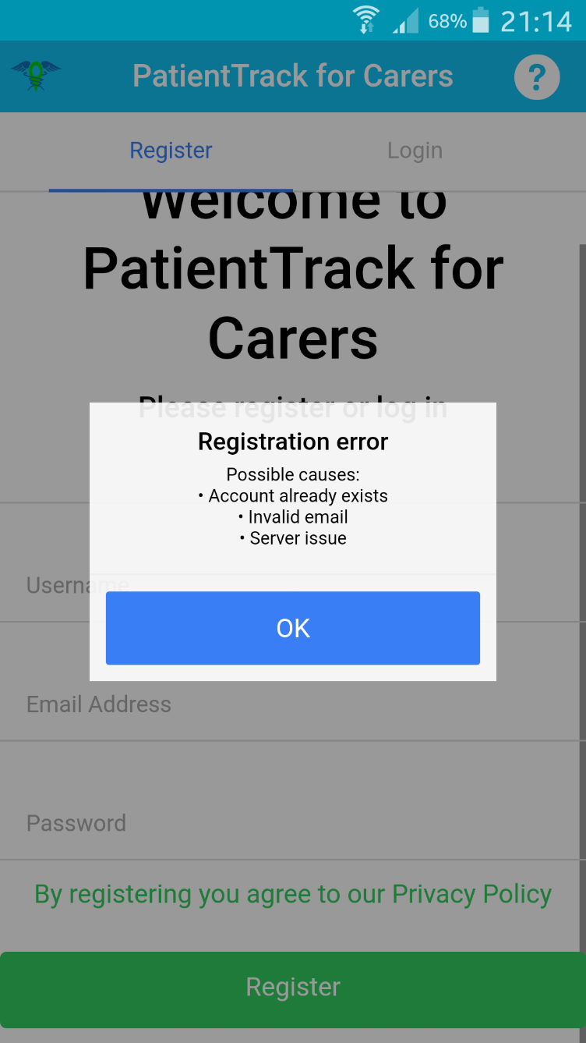

Figure - Registration Error Message

Another colleague’s feedback mentioned that the map to track the patient should have a marker so that the specific location of the patient can be pinpointed, rather than a map of their general location. This is shown in Figure 39.

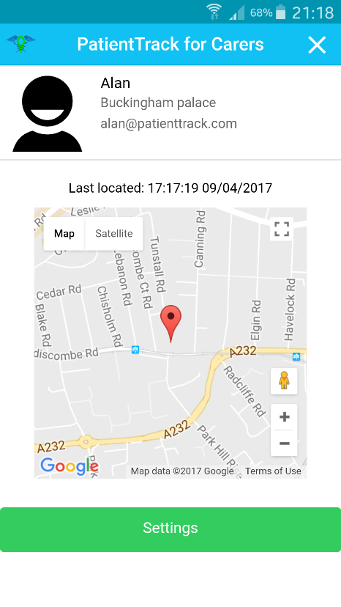

Figure – Map Marker

Finally, other feedback suggested that the ‘Home’ button in the patient’s app was too small. Therefore, the button’s CSS was altered to ensure it was responsive to the size of the screen, and took up a large portion of the screen (Figure 40).

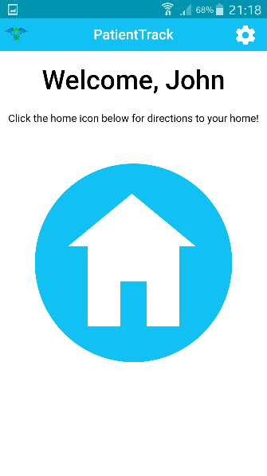

Figure - Large Home Button

* 1. Legal, Social, Ethical, and Professional Considerations

In the Technical Review section, several laws were mentioned to which the applications must adhere, alongside some other issues which it would be unethical to cause. This section explains how the applications avoided, or resolved each of these issues.

The Data Protect Act is a law which requires all applications to; be honest in how personal data is used, keep data secure, and keep accurate data. To ensure the user knows how data will be used, a privacy policy has been added which has a quick summary at the top to explain to users what data is collected. The data is stored on a Microsoft Azure server, which are kept very secure – also, user’s data is only available using an API – so the database cannot be hacked using SQL injection. Finally, the user is able to update data from within the application, so all data is kept up to date.

The Equality Act states that the application must not exclude anyone from using it. Colours have been used throughout the apps, but they are not required for any function, so that colour-blind users may use the app without any reduced functionality.

The applications ease pressure put on carers to look after their patients at all times, as they can now remotely track their patients to ensure that they have not begun wandering.

Above the register and login buttons on both applications, there is a link to the privacy policy, which states that by registering and logging in the user agrees to the privacy policy. Therefore, users have given their consent to how their data is used.

Dementia is an incredibly costly disease, so to avoid any further expense these applications are free. They are also free of advertising, to ensure that the apps can be used easily.

Finally, the apps have been tested extensively to ensure that the app will not crash on the user, as this could be confusing – particularly for users with Dementia.

1. Testing

This section discusses the use of testing within the development of the PatientTrack applications. Testing helped to ensure that the apps were bug-free, and that they met the requirements specification fully.

* 1. Testing Method
     1. Manual / Black Box Testing

Black Box testing has been the main method used to test the applications. To complete these tests, a test plan was created which involves trying various types of input on each feature, writing the expected outcome, and comparing what the actual outcome was. These tests created results which demonstrated which elements of the system work well, and which need improving.

* + 1. Questionnaires to Colleagues

At significant points of development, colleagues were given questionnaires to fill in regarding the application. This questionnaire included a rating system for features such as performance, usability, and error handling. These questionnaires were very useful in gathering actionable feedback.

* + 1. Unit Testing

Unit tests are a very useful tool, as these can be run to gather results almost immediately each time code is delivered. Unfortunately, it was not possible to implement these in this project as some issues were encountered in configuring the software. However, researching how unit tests are completed on an Angular system ensured that future projects would not have this issue. Angular (2017), suggest using Karma and Jasmine – two frameworks which work together to give readable unit tests.

* 1. Testing Prototypes
     1. Prototype 1

The tests created for the first prototypes were developed solely to test the registration and login features of the applications.

As both applications contained the same functionality at this point, the tests for each were very similar. These tested that the user could not leave any of the form’s text boxes blank, and that when suitable data is inserted, the user is successfully registered and logged in.

One error encountered during registration is that, while inputs of type ‘text’ that are empty have the value of “undefined”, empty inputs of type ‘password’ have the value “”. Therefore, the user could leave the password box empty, leaving their account unprotected. To resolve this, all input boxes were enclosed within a <form> element, and given a “required” tag. Then, the button’s “ng-disabled” value was set to the value of if the form is invalid (e.g. “form1.$invalid”) – therefore if the form is invalid, the button will be disabled. This resolved the issue, so the process was repeated for all forms in the apps before continuing testing.

* + 1. Prototype 2

The second prototypes implemented features to connect the patients and carers. At this stage, the applications had very different features, with the carer’s application containing many more features than the patient’s.

The tests for the patient’s application ensured that the user could navigate to the settings page, and that they could view their ‘PatientCode’ from here. As there is no extra data input required, the tests for this prototype were very simple.

The tests for the carer’s application were slightly more complex. Firstly, the add patient functionality was tested by ensuring that the user could add a patient using their patient code. Then, the tests check that the patient is then added to the carer’s list of patients on the home screen. Next, the tests attempted to insert any other data into the ‘Add Patient’ popup, to check that it would simply state ‘Patient not found’ if the code is invalid. Finally, tests were run to ensure that if the carer added a patient with whom they were already connected, that the connection was not duplicated.

* + 1. Prototype 3

The third prototypes were focused on retrieving, storing, and displaying the location of the patient.

The tests for the patient’s app checked that the location was sent every 30 seconds, and that this did not interfere with the patient using the app. It also checked various error cases such as the patient having their WiFi, data, or location disabled on their device. Testing this uncovered an issue – if the patient has any of the aforementioned services disabled, the location is not uploaded, and the patient is not notified of this. To resolve this, a popup feature was implemented which uses the Cordova Diagnostics and Network Information plugins to notify the user if they are not connected to the internet, or have their location disabled, with the option to go to the appropriate settings page to enable the service. These tests also ensured that the user can easily use the application to get directions to their stored address.

The tests for the carer app covered viewing the most recent location of the patient’s they’re connected with. Primarily ensuring that the carer can access the patient’s details page from the home page, and subsequently testing that all features on the patient’s details page are displayed appropriately. There were no issues discovered through testing the carer’s app.

* + 1. Prototype 4

The functionality implemented in the fourth prototypes implemented several smaller features, such as updating usernames, passwords, and addresses. Other features tested include the sign out and delete account functionality. They also tested that, in both apps, the user can access a help page and the privacy policy.

It was decided that – to ensure a patient does not delete their account while they still require carers – if the patient’s account is connected to any carer’s accounts, they are unable to delete their account. The issue around this is that, upon attempted deletion, the patient was shown a basic error message with no explanation as to why they cannot delete their account. To improve this a feature was implemented which displays the names and email addresses of all carers connected with the patient.

In addition to the shared functionality above, the carer app tests covered the patient settings functionality. This includes deleting a carer-patient connection, and updating the patients address. One issue encountered during these tests was that the updated address has no validation, so the carer can enter any text for this value.

* 1. Legal, Social, Ethical, and Professional Considerations in Testing

Due to the intended audience of the PatientTrack applications, it was very important that the systems were bug free, easy to use, and did not offer inappropriate functionality.

Therefore, testing the applications had to ensure that – regardless of the user’s input on any text box – the apps did not crash, as this could be disorientating and confusing for the user. It was also important to explore various error scenarios such as a lack of internet connection, so that users can be notified if the systems aren’t working to their full potential.

The user surveys, given to colleagues, demonstrated the usability of the systems, and pointed out any flaws in the systems. They also assisted to produce ideas regarding improvement of specific features, or ideas for entirely new features. Finally, the user survey responses were very useful in locating features which might be inappropriate for the user.

1. Evaluation

This section contains an evaluation of the created apps. The main approach used to evaluate the products was a heuristic evaluation, using Nielsen’s heuristics. This section also describes how the project may be developed further. A full demonstration of the apps’ functionality can be found in Appendix A.

* 1. Heuristic Evaluation

|  |  |
| --- | --- |
| **Heuristic** | **Evaluation** |
| Visibility of system status | The PatientTrack applications provide constant feedback using popup messages when the user attempts to complete any action such as changing the user’s username and password. |
| Match between system and the real world | The system is currently only available in English. However, no complex terms are used, and data – such as the patients connected to a carer – is displayed in a logical format (in this case, a list). |
| User control and freedom | All pages which navigate away from the home page of each app have a cross symbol in the top right of the window. The system does not support undoing of changing username and password, as this is more secure. |
| Consistency and standards | The ‘close’ button, featured on non-home pages - is a common convention to close the current page, and is used on many systems. The ‘Navigate home’ button in the patient’s app contains an icon of a house, an image commonly used for this function. |
| Error prevention | There were no situations found which caused the apps to crash. All error scenarios which require user input, such as a user having no internet connection, notify the user using a simple popup, with options to fix the issue. |
| Recognition rather than recall | All buttons are clearly visible, and take up the width of the page. This ensures that the user can understand the function of each button. There are no situations in which the user is required to memorise information across pages. Instructions for using the system are available from the login, register, and settings pages. All of which are very easily accessible. |
| Flexibility and efficiency of use | There are very few accelerators available for experienced users of the system, as all functionality can be accessed within a few button presses. The functions are very easy to use, as the system is aimed at the elderly. |
| Aesthetic and minimalist design | The apps use a very minimalistic design, with no unnecessary information being displayed on the pages. All popup messages are concise and clear. |
| Help users recognize, diagnose, and recover from errors | No error codes are displayed in error messages, all error messages contain some details of what caused the issue, and what can be done to fix it. |
| Help and documentation | Even before registering, the user can access a help page which explains how to use the applications, and what they can be used for. The systems are very intuitive, so it is unlikely that the user would require this, however it is also available from the settings page, should it be required. |

* 1. Requirements Evaluation

The evaluation of functional and non-functional requirements is available in Appendix B.

All must and should prioritised requirements have been met – as such, the system can be deemed to be successfully, but not fully, implemented.

The functional requirements which have been met ensure that the system contains more functionality than the proposed Minimal Viable Product (MVP). The non-functional requirements that have been met ensure that the system meets legal requirements, and that the system is usable by everyone.

All requirements which have not been met at present would be developed in future iterations.

* 1. Future Development

There are some functional requirements which were not developed within this project. These were all prioritised as ‘Could’ or ‘Would’ have, as such were not necessary for the Minimum Viable Product. These features are:

* Information regarding Dementia
* Login using alternative methods (i.e. Facebook and Google)
* Notifying carer when patient requests navigation
* A medication reminder for patients
* Analysis of patient’s walking patterns to determine if they are wandering
* Music therapy

There are several other features which could be implemented in the future to improve the systems. These are:

* Memory games
* A contact book, with images, to help in remembering people
* Links to useful websites
* A place for patients to take notes of any questions they have
* Validation of patient’s address
* A ‘Forgotten password’ link.

1. Critical Appraisal

This section contains an appraisal of the process used in this project, and an evaluation of the author.

* 1. Process Evaluation

This project has used the DSDM framework as a methodology. This has helped in the design and development stages of the project. Tools and practises prescribed by DSDM have been used to simplify these processes.

Using MoSCoW rules to analyse the requirements helped to prioritise which features to develop first, and decide which can be left for future development. This could have been used more effectively by iteratively altering the priorities of the requirements.

Using timeboxing to set a time limit for developing features enabled the design and development to be completed on schedule. These were mostly adhered to. However, there were some instances in which the development over-ran.

Creating prototypes in the design stage assisted in testing various user interfaces and deciding on which are the most suitable.

Developing the systems iteratively ensured that the systems were testable at many stages of development, allowing for more specific, valuable feedback.

The tools used for the development of the apps aided the process greatly. Using GitHub to store code and documents ensured that the apps were available at all times, and provided security for if the laptop used for development became faulty. On top of this, the Chrome plugin – ZenHub – was incredibly useful at task management as this provided a visual interface for creating tasks, managing the backlog, and viewing generated charts such as burndown and velocity charts. The charts are not particularly useful in a project of this length, as they are normally used to demonstrate how much work has been done, and how much can be expected to be completed in the future.

In conclusion, using the DSDM framework and tools such as ZenHub has improved and simplified the process of creating the applications. However, increasing the length of the project and adhering to the practises more thoroughly may have kept the development more on schedule, allowed for more high-priority functionality to be developed, and allowed for the tools to be used more effectively.

* 1. Author Evaluation

As the author had no previous experience of using the Ionic framework and Angular JS, the development of the applications was a very daunting task to begin with. However, a knowledge of other object oriented programming languages – such as Java, C#, and NodeJS – assisted in learning the technologies used in this project.

Using information taught throughout university enabled the project to use the DSDM framework effectively, which helped to produce a better final product. This project allowed the author to see the framework used in a practical setting, which helped to better understand why a methodology or framework is important in a software development project. In future projects, it would be interesting to see how the tools and practises prescribed by DSDM can be implemented and improved to further simplify the developmental process.

Strict use of time planning and task assignment has been key to the success of this project. Ensuring that the systems have been developed within the timeboxes was challenging, but the tasks were completed to a good standard as a result of long hours of work for up to 27 consecutive days (according to GitHub’s commit log).

Better research into development methods and technologies used may have reduced the issues encountered, such as not being able to create unit tests for the systems. This is a lesson which the author has learned as a result of this project, and will be applied in subsequent projects.

In conclusion, this project has been a steep learning curve for the author, and has required a considerable amount of self-study to gather the skills required to effectively develop the apps. However, it has been a rewarding experience – and skills learned in this project can be transferred to improve future projects.

1. Conclusion

This project investigated how mobile applications and location based services can assist people with Dementia and their carers.

The literature review section researched and discussed topics such as Location Based Services (LBS) within Android Development, Issues that Carers of people with Dementia have, and available therapies which can be used to assist and treat people with Dementia. These topics aided in the design of the applications vastly as they investigated how the apps could be developed, and which features would be valuable to include within the apps.

The initial design stages of this project ensured that the systems developed were able to meet the requirements created from the literature review, and that the systems had a usable UI. Further design stages after each iteration of the prototype allowed for each feature to be fine-tuned based on feedback and testing.

The development stages were very exciting, yet challenging. There were some issues encountered, mostly due to a lack of experience in the types of system being developed. However, this allowed the author to learn and grow – and has been a rewarding experience.

In conclusion, this project has been very successful – but was not without its issues. If the project were to be repeated, more care would be taken to understand the technologies that are required for the development, so that fewer problems are encountered during the development stages.

1. References
2. Algase, D.L., Moore, D.H., Vandeweerd, C. and Gavin-Dreschnack, D.J., (2007) Mapping the maze of terms and definitions in dementia-related wandering. Aging & mental health, 11(6), pp.686-698.
3. Alzheimer’s Association (2016) Home Safety and Alzheimer's | Caregiver Center | Alzheimer's Association, Alzheimer's Association, [online] Available at: https://www.alz.org/care/alzheimers-dementia-home-safety.asp (Accessed Nov 23, 2016).
4. Alzheimer's Association (2016). Three out of Five People with Alzheimer's Disease Will Wander, Alzheimer's Association. [online] Available at: http://www.alz.org/norcal/in_my_community_18411.asp (Accessed Nov 4, 2016)
5. Alzheimer's Society. (2016) Facts for the Media. [ONLINE] Available at: https://www.alzheimers.org.uk/site/scripts/documents_info.php?documentID=535&pageNumber=2. (Accessed Oct 17, 2016).
6. American Music Therapy Association (2016) What is Music Therapy | What is Music Therapy? | American Music Therapy Association (AMTA), [online] Available at: http://www.musictherapy.org/about/musictherapy/ (Accessed Nov 23, 2016).
7. Android (2016). Saving Key-Value Sets | Android Developers. [online] Developer.android.com. Available at: https://developer.android.com/training/basics/data-storage/shared-preferences.html (Accessed Dec 12, 2016).
8. AngularJS (2017).*AngularJS*. [online] Available at: https://docs.angularjs.org/guide/unit-testing [Accessed 9 Apr. 2017].
9. Brunnström, H.R. and Englund, E.M., (2009) Cause of death in patients with dementia disorders. European Journal of Neurology, 16(4), pp.488-492.
10. Care2. (2017). [online] Available at: http://dingo.care2.com/pictures/greenliving/1339/1338656.large.jpg [Accessed 22 Apr. 2017].
11. Chen, P.T. and Lin, Y.S., (2011) Mobile Location-Based Services: An Empirical Study of User Preferences. International Journal of Information and Education Technology, 1(5), p.416.
12. Cipriani, G., Lucetti, C., Nuti, A. and Danti, S., (2014) Wandering and dementia. Psychogeriatrics, 14(2), pp.135-142.
13. Cohen‐Mansfield, J. and Billig, N., (1986) Agitated behaviors in the elderly: I. A conceptual review. Journal of the American Geriatrics Society, 34(10), pp.711-721.
14. Damm, S. (2013). IDE Comparison for HTML 5, CSS 3 and JavaScript. [online] Available at: http://www.oio.de/public/opensource/comparison-IDE-for-HTML5-CSS3-JavaScript-shootout.htm (Accessed Dec 12, 2016).
15. Desai, A.K., Schwartz, L. and Grossberg, G.T., (2012) Behavioral disturbance in dementia. Current psychiatry reports, 14(4), pp.298-309.
16. Díaz-Ramírez, A., Murrieta, F.N., Atempa, J.A. and Bonino, F.A., (2013) May. Non-intrusive tracking of patients with dementia using a wireless sensor network. In 2013 IEEE International Conference on Distributed Computing in Sensor Systems (pp. 460-465). IEEE.
17. Family Caregiver Alliance (2016) Home Away from Home: Relocating Your Parents [online] Available at: https://www.caregiver.org/home-away-home-relocating-your-parents (Accessed Nov 23, 2016)
18. GeoMarketing. (2016) Overwhelming Number Of Smartphone Users Keep Location Services Open. [online] Available at: http://www.geomarketing.com/overwhelming-number-of-smartphone-users-keep-location-services-open. (Accessed Oct 31, 2016).
19. Google. (2017) Creating Apps with Material Design, [online] Available at: https://developer.android.com/training/material/get-started.html (Accessed Feb 1, 2017)
20. Gov.uk. (2016). Data protection - GOV.UK. [online] Available at: https://www.gov.uk/data-protection/the-data-protection-act (Accessed Dec 12, 2016).
21. Gov.uk. (2016). Making your service accessible: an introduction - Digital Service Manual - GOV.UK. [online] Available at: https://www.gov.uk/service-manual/helping-people-to-use-your-service/making-your-service-accessible-an-introduction (Accessed Dec 12, 2016).
22. Ionic (2016) Ionic Framework, [online] Available at: http://ionicframework.com/ (Accessed Dec 9, 2016).
23. Ionic Framework. (2017).*Ionic Framework*. [online] Available at: http://ionicframework.com/docs/ [Accessed 9 Apr. 2017].
24. IonicMaterial (2017) Ionic Material / Material Design / Ionic Framework / AngularJS / Zach Fitzgerald [online] Available at: http://ionicmaterial.com/index.html (Accessed Feb 1, 2017).
25. JetBrains. (2016). WebStorm: The Smartest JavaScript IDE. [online] Available at: https://www.jetbrains.com/webstorm/ (Accessed Dec 9, 2016).
26. Klein, D.A., Steinberg, M., Galik, E., Steele, C., Sheppard, J.M., Warren, A., Rosenblatt, A. and Lyketsos, C.G., (1999) Wandering behaviour in community-residing persons with dementia. Int. J. Geriat. Psychiatry, 14, pp.272-279.
27. Kosta, E., Zibuschka, J., Scherner, T. and Dumortier, J., (2008) Legal considerations on privacy-enhancing location based services using PRIME technology. Computer Law & Security Review, 24(2), pp.139-146.
28. Kwok, T.C., Yuen, K.S., Ho, F.K. and Chan, W.M., (2010) Getting lost in the community: a phone survey on the community‐dwelling demented people in Hong Kong. International journal of geriatric psychiatry, 25(4), pp.427-432.
29. Lambture, E.M. and Shaikh, Z.M., (2016) Android application for text based location services. International Research Journal of Engineering and Technology, 3(4), pp.2181-2184
30. Maiden, N., D'Souza, S., Jones, S., Müller, L., Pannese, L., Pitts, K., Prilla, M., Pudney, K., Rose, M., Turner, I. and Zachos, K., (2013) Computing technologies for reflective, creative care of people with dementia. Communications of the ACM, 56(11), pp.60-67.
31. Matthews, S., (2015) Dementia and the Power of Music Therapy. Bioethics, 29(8), pp.573-579.
32. McDermott, O., Orrell, M. and Ridder, H.M., (2014) The importance of music for people with dementia: the perspectives of people with dementia, family carers, staff and music therapists. Aging & mental health, 18(6), pp.706-716.
33. Milne, H., van der Pol, M., McCloughan, L., Hanley, J., Mead, G., Starr, J., Sheikh, A. and McKinstry, B., (2014) The use of global positional satellite location in dementia: a feasibility study for a randomised controlled trial. BMC psychiatry, 14(1), p.1.
34. Naturalnews. (2017). [online] Available at: http://www.naturalnews.com/gallery/640/Men/Elderly-Man-Old-Worried-Sad-Depressed-Thinking.jpg [Accessed 22 Apr. 2017].
35. Nellsar. (2017). [online] Available at: http://www.nellsar.com/sites/default/files/styles/grid-8-breakpoints_theme_nellsar_md_1x/public/BP_MALE_CARER_1430x592.jpg?itok=YFFOzj5K [Accessed 22 Apr. 2017].
36. Netbeans.org. (2016). Welcome to NetBeans. [online] Available at: https://netbeans.org/ (Accessed Dec 12, 2016).
37. NHS. (2017) NHS Identity Guidelines | Colours [online] Available at: https://www.england.nhs.uk/nhsidentity/identity-guidelines/colours/ (Accessed Feb 4, 2017)
38. Nielsen, J., (1995) 10 Heuristics for User Interface Design: Article by Jakob Nielsen, 10 Heuristics for User Interface Design: Article by Jakob Nielsen, [online] Available at: https://www.nngroup.com/articles/ten-usability-heuristics/ (Accessed Nov 28, 2016).
39. Oh, H. and Gross, M.D., (2015) September. Awareable steps: functional and fashionable shoes for patients with dementia. In Adjunct Proceedings of the 2015 ACM International Joint Conference on Pervasive and Ubiquitous Computing and Proceedings of the 2015 ACM International Symposium on Wearable Computers (pp. 579-583). ACM.
40. Our Code World. (2016). Top 7 : Best free web development IDE for JavaScript, HTML and CSS. [online] Available at: http://ourcodeworld.com/articles/read/200/top-7-best-free-web-development-ide-for-javascript-html-and-css (Accessed Dec 9, 2016).
41. Raj, J. (2014) The Top 7 Hybrid Mobile App Frameworks, SitePoint, [online] Available at: https://www.sitepoint.com/top-7-hybrid-mobile-app-frameworks/ (Accessed Dec 9, 2016).
42. Robinson, L., Hutchings, D., Corner, L., Beyer, F., Dickinson, H., Vanoli, A., Finch, T., Hughes, J., Ballard, C., May, C. and Bond, J., (2006) A systematic literature review of the effectiveness of non-pharmacological interventions to prevent wandering in dementia and evaluation of the ethical implications and acceptability of their use. HEALTH TECHNOLOGY ASSESSMENT-SOUTHAMPTON-, 10(26).
43. Ryschka, S., Murawski, M. and Bick, M., (2016). Location-Based Services. Business & Information Systems Engineering, 3(58), pp.233-237.
44. Sasaki, H., (2016) May. A smartphone app provides preventive care for the elderly with dementia. In Data Engineering Workshops (ICDEW), 2016 IEEE 32nd International Conference on (pp. 50-53). IEEE.
45. Schiller, J. and Voisard, A. eds., 2004. *Location-based services*. Elsevier.
46. SearchSoftwareQuality. (2016). What is integrated development environment (IDE)? - Definition from WhatIs.com. [online] Available at: http://searchsoftwarequality.techtarget.com/definition/integrated-development-environment (Accessed Dec 9, 2016).
47. Shree, S.B., Sheshadri, H.S., Shivakumar, R. and Kumar, H.V., (2014) December. Design of embedded system for tracking and locating the patient suffering from Alzheimer's disease. In Computational Intelligence and Computing Research (ICCIC), (2014) IEEE International Conference on (pp. 1-5). IEEE.
48. Sims, G. (2016) I want to develop Android Apps - What languages should I learn?, Android Authority, [online] Available at: http://www.androidauthority.com/want-develop-android-apps-languages-learn-391008/ (Accessed Dec 9, 2016).
49. Smith, A. (2014) Older Adults and Technology Use, Pew Research Center Internet Science Tech RSS, [online] Available at: http://www.pewinternet.org/2014/04/03/older-adults-and-technology-use/ (Accessed Nov 2, 2016)
50. Sublime (2016). Sublime Text: The text editor you’ll fall in love with. [online] Available at: https://www.sublimetext.com/ (Accessed Dec 12, 2016).
51. Techopedia (2016) What are Location Based Services (LBS)? - Definition from Techopedia. [online] Available at: https://www.techopedia.com/definition/12888/location-based-services-lbs (Accessed Nov 14, 2016).
52. Telegraph. (2016) Android roars back in strongest growth in two years, as iOS shrinks. [ONLINE] Available at: http://www.telegraph.co.uk/technology/2016/05/17/android-roars-back-in-strongest-growth-in-two-years-as-apple-shr/. (Accessed Oct 16, 2016).
53. Usability.gov, (2016) Heuristic Evaluations and Expert Reviews, Heuristic Evaluations and Expert Reviews | Usability.gov, [online] Available at: https://www.usability.gov/how-to-and-tools/methods/heuristic-evaluation.html (Accessed Nov 28, 2016).
54. W3Schools (2017). AngularJS Tutorial. [online] Available at: https://www.w3schools.com/angular/ [Accessed 9 Apr. 2017].
55. W3schools.com. (2016). SQL Injection. [online] Available at: http://www.w3schools.com/sql/sql_injection.asp (Accessed Dec 12, 2016).
56. www.tutorialspoint.com. (2016). Android Shared Preferences. [online] Available at: https://www.tutorialspoint.com/android/android_shared_preferences.htm (Accessed Dec 12, 2016).
57. Yamakawa, M., Yoshida, Y., Higami, Y., Shigenobu, K. and Makimoto, K., (2014) Caring for early‐onset dementia with excessive wandering of over 30 kilometres per day: a case report. Psychogeriatrics, 14(4), pp.255-260.
58. Zickuhr, K., (2012) Three-quarters of smartphone owners use location-based services. Pew Internet & American Life Project.
59. Ziflaj, A. (2014) Native vs Hybrid App Development, SitePoint, [online] Available at: https://www.sitepoint.com/native-vs-hybrid-app-development/ (Accessed Dec 9, 2016).
60. Bibliography
61. Alzheimer’s Society, 2016. Challenges facing primary carers of people with Dementia: Opportunities for research. Challenges facing primary carers of people with Dementia
62. Burns, A., 1992. Cause of death in dementia. International journal of geriatric psychiatry, 7(7), pp.461-464.
63. Galeana-Zapién, H., Torres-Huitzil, C. and Rubio-Loyola, J., 2014. Mobile Phone Middleware Architecture for Energy and Context Awareness in Location-Based Services. Sensors, 14(12), pp.23673-23696.
64. Hadjioannou, V., Mavromoustakis, C.X., Mastorakis, G., Markakis, E.K., Valavani, D. and Pallis, E., 2016, July. Context awareness location-based Android application for tracking purposes in assisted living. In Telecommunications and Multimedia (TEMU), 2016 International Conference on (pp. 1-7). IEEE.
65. Holzer, C. and Warshaw, G., 2000. Clues to early Alzheimer dementia in the outpatient setting. Archives of Family Medicine, 9(10), p.1066.
66. Kumar, S., Qadeer, M.A. and Gupta, A., 2009, January. Location based services using android. In Proceedings of the 3rd IEEE international conference on Internet multimedia services architecture and applications, ser. IMSAA (Vol. 9, pp. 335-339).
67. Lin, Y.J., Chen, H.S. and Su, M.J., 2015, January. A cloud based Bluetooth Low Energy tracking system for dementia patients. In Mobile Computing and Ubiquitous Networking (ICMU), 2015 Eighth International Conference on (pp. 88-89). IEEE.
68. Reto, M., 2009. Professional android application development. Word Programmer to Programmer, 6(7), pp.1794-1797.
69. Wick, J. and Zanni, G., 2006. Aimless excursions: wandering in the elderly. The Consultant Pharmacist®, 21(8), pp.608-618.
70. Yamagata, C., Coppola, J.F., Kowtko, M. and Joyce, S., 2013, May. Mobile app development and usability research to help dementia and Alzheimer patients. In Systems, Applications and Technology Conference (LISAT), 2013 IEEE Long Island (pp. 1-6). IEEE.
71. Appendices
72. System Functionality
    1. PatientTrack for Carers

This section contains screenshots and explanations of each page of the carer app developed for this project.

* + 1. Registration

|  |  |
| --- | --- |
| This is the Registration page. From here, the user can fill in the form with their personal details, this will enable the Register button (at the bottom of the screen).  From this page, the user can also access the Help page (by clicking the ‘?’ icon on the right of the navigation bar), the Privacy Policy (by clicking the link above the register button), and the Login page (by using the Login tab). | Figure |
| Once the register button has been clicked, the system will register the user, and a popup confirmation will be displayed. The user is then redirected to the Login page. | Figure |

* + 1. Login

|  |  |
| --- | --- |
| Using the email address and password that they registered with, the user can log into the system from this page. Again, from here they have access to the Help and Privacy Policy pages, and they may also return to the Register page. | Figure |

* + 1. Help

|  |  |
| --- | --- |
| The Help page contains information regarding what the system is for, and how it is used. It also has details on the developer, to be used if a question is not answered on this page. | Figure |

* + 1. Privacy Policy

|  |  |
| --- | --- |
| The Privacy Policy page contains the full privacy policy. This was generated using iUbenda.  The top section of the page contains the policy summary – so that a user may quickly see what data is collected and stored, and what it is used for.  The rest of the page contains the full details of the policy. | Figure |

* + 1. Home

|  |  |
| --- | --- |
| Once logged in, the Home page contains very little information to begin with. The user can click the settings button to open the settings page, or they may click the ‘+’ button on the navigation bar to add a patient. | Figure |
| If the user clicks the ‘+’ button, a popup is displayed. This enables the user to enter the patient’s code (found within the patient app). If the code is correct, the patient’s details are added to the carer’s home page. | Figure |
| This image demonstrates a successful connection with a patient. If the user enters and invalid patient code, they are shown a popup containing an error message. | Figure |

* + 1. Settings

|  |  |
| --- | --- |
| The settings page contains many functions for the user. From here, they may:   * Change their username * View the privacy policy * View the help page * Change their password * Delete their account * Sign out   The functions which may have a severe impact on their account are under a heading titled ‘Danger Zone’. | Figure |
| If the user enters a value to change their username, the name displayed on the home page is updated and then a confirmation popup is displayed. | Figure |

* + 1. Change Password

|  |  |
| --- | --- |
| On the Change Password page, the user must enter their current password, and the desired new password twice (to avoid typos) to change their password. If there are any issues with the data used in the form – such as an incorrect password, or mismatching new passwords – the user is shown a popup with an error message explaining the problem. | Figure |

* + 1. Patient Details

|  |  |
| --- | --- |
| If the user selects a patient from their home page, they are shown their name, address, email, most recent location, and time located.  This page uses the Google Maps API to display the map widget.  The user can click on the settings button to go to the patient settings page. | Figure |

* + 1. Patient Settings

|  |  |
| --- | --- |
| From the patient settings page, the carer may alter the patient’s address, and delete the connection with the patient. | Figure |

* 1. PatientTrack for Patients

This section contains screenshots and explanations of each page of the patient app developed for this project.

* + 1. Register

|  |  |
| --- | --- |
| The registration page for the patient app is very similar to the carer app. The user can access the Help, Privacy Policy, and Login pages. The only difference in the form is that the user is required to enter their address, which is used for navigation purposes. | Figure |
| Upon successful registration, the user is redirected to the login page and shown a confirmation popup message. | Figure |

* + 1. Login

|  |  |
| --- | --- |
| The login page is very similar to the carer’s login page. With links to the Help, Privacy Policy, and Register pages.  The Login button is only enabled once the form has been filled in. | Figure |

* + 1. Help

|  |  |
| --- | --- |
| The Help page contains information on what the app is used for, how to use the app, and how to contact the developers with further questions. | Figure |

* + 1. Privacy Policy

|  |  |
| --- | --- |
| The Privacy Policy page contains a policy generated from iUbenda. This has a summary at the top of the page, and the full policy further down. | Figure |

* + 1. Home

|  |  |
| --- | --- |
| The home page is intentionally very simple in the patient app. There is a settings button on the right of the navigation bar which opens the settings page.  Clicking the home button opens the Google Maps app, which provides navigation from the user’s current location to the address stored on the system. | Figure |

* + 1. Navigation (Google Maps)

|  |  |
| --- | --- |
| This is an example of the navigation provided by Google Maps after the user has clicked the Home navigation button. The user is provided with different options for getting home, such as various public transport routes, walking routes, and the option to order a taxi.  N.B. The image displayed is not the author’s own work. | Figure .  Source: https://www.google.co.uk/maps |

* + 1. Settings

|  |  |
| --- | --- |
| The settings page contains the following functions:   * Change username * View Privacy Policy * View Help Page * Change Password * Delete Account * Sign Out   These features work in the same way as in the carer app.  The user is also shown their patient code, which is used by the carer to connect with the patient. | Figure |
| If the user clicks on the Delete Account button, they are asked to enter their password to confirm.  If this is correct then they may successfully delete the account, if not then they are shown an error message. If the user leaves this popup open for more than 10 seconds, the popup closes – this is so that the account cannot be accidentally deleted. | Figure |

* + 1. Change Password

|  |  |
| --- | --- |
| The change password page requires the user to enter their current password, and the desired new password twice, to ensure that they are authorised and that they have not made a typo. | Figure |

1. Requirements Evaluation
   1. Non-functional Requirements Evaluation

| **Requirement** | **MoSCoW** | **Has Been Met** | **Description** |
| --- | --- | --- | --- |
| The system’s database must not be vulnerable to SQL injection | Must | Yes | The apps call a private API, as such the database is not called directly from within the apps. Therefore, no SQL injection can occur. |
| The applications must provide a privacy policy | Must | Yes | Both applications contain a privacy policy, created using iUbenda. |
| The systems must use a clear font and colour scheme to ensure the visually impaired are not at any disadvantage | Must | Yes | The systems use colours provided by Ionic’s bootstrap CSS. These are designed to be colour-blind friendly. The systems also use a clear and large font to ensure they are readable. |
| The patient system must request the user’s consent to track them | Must | Yes | Before the user register’s and logs in, the app states that by registering the user agrees to the privacy policy. This contains all the details on how the user’s data will be stored and used. |
| The systems should be able to handle errors (such as one device failing) and continue to operate - albeit at a reduced functionality | Should | Yes | If the patient’s device fails, the carer’s app still functions – it just uses the most recently stored location of the patient. |
| The systems should be fully tested | Should | Partially | The systems have been fully black-box tested. However, they have not been unit tested. |
| The systems should have de-coupled, cohesive code to allow for easy improvements in the future | Should | Yes | The systems use a Model-View-Controller pattern – commonly used in Angular applications. |
| The system could perform well (provided there is time in this project), providing the user with their patient’s location or their route home without unreasonable delay | Could | Partially | The system completes API calls quickly, after the first one. This is believed to be caused by the API server going into a ‘standby’ mode on the Azure server. No performance testing has been completed on the applications. |
| The systems would be ported to iOS if there was more time as will be developed on the hybrid platform ‘Ionic’. This port should have no more or less functionality than its Android counterpart and should work across platforms (i.e. Carer on iOS and patient on Android) | Would | No | The systems have not yet been ported to iOS. This is easily achievable using ionic. This has not been completed as access to an iPhone on which to test this was not possible. |

* 1. Functional Requirements Evaluation

| **Requirement** | **Fulfilled?** | **Explanation** | **Screenshot** |
| --- | --- | --- | --- |
| The carer system must allow the carer to remotely view the most recently accessed location of their patient | Yes | The carer can connect with a patient by entering a patient’s unique code. They can then click on the patient to view their last known location, and time located. | Figure |
| The patient system must allow the user to access navigation to their home with Google Maps through a simple user interface | Yes | The patient must enter their address upon registration (this can be changed using the carer’s app), once logged in, the patient can click a single button (the home icon in Figure 65) to be transferred to Google Maps navigation to their home address. | Figure |
| The systems must ensure that the users enter their details on the first use, and that these details are not requested in subsequent uses | Yes | Both systems make use of LocalStorage to store key-value pairs for the user’s username and password. These are stored until the user delete’s their account or logs out. When the user re-opens the app, they are automatically logged in without any details being requested. | *Figure 66* |
| The carer system must allow the user to track a patient using their uniquely generated code. | Yes | When a patient registers, their email address is used to create a 7-character code. This can be viewed from the patient’s settings page (Figure 67) and then used in the carer’s app (Figure 68) to create a connection (Figure 69). | Figure    Figure    Figure |
| The systems should have a tutorial page which explain how to use the apps. | Yes | Both systems have a “?” icon in the navigation bar on the register page, login page, and settings page. This links to a page which explains the use of the apps and answers to some other questions. | Figure    Figure |
| The carer system should allow the carer to track more than one patient | Yes | The Carer can use their app to connect with as many patients as they require. | Figure |
| The systems should allow the user to change their password | Yes | Both apps allow the user to change their password, this feature requires them to enter their current password correctly, as well as two matching passwords. | Figure    Figure |
| The systems should allow the user to change their username | Yes | Both apps allow the user to easily change their username. As this is only for display it does not require any verification. | Figure    Figure |
| The systems should allow the carer to change the patient’s home address (this is more secure than allowing the patient to change their own address) | Yes | Once the carer has made a connection with the patient, they may change their address by clicking on them, and the selecting ‘Settings’. This feature is only in the carers app as a person with Dementia may accidentally change the address to an incorrect one. | Figure    Figure |
| The systems could offer information about Dementia - particularly topics discussed in the literature review such as dangers, preventative measures, and treatments | No | It was not possible to implement this within the given time, it would be programmatically simple to complete, but would require more research into Dementia. | No image |
| The systems could allow the users to log in with alternative methods such as Facebook and Google | No | It was not possible to complete this within the given time, Facebook and Google login APIs were researched, but were not implemented. | No image |
| The system could notify the carer when the patient has requested navigation home | No | It was not possible to complete this within the given time, to do this a Cordova plugin called “Phonegap-plugin-push” would be used. | No image |
| The patient system would have a medication reminder if there was more time to develop it | No | It was not possible to implement this due to time constraints. However, this would be a useful feature for future development. | No image |
| The patient system would analyse the user’s actions to determine how often they get lost, and attempt to discover patterns. These would be retrievable from the carer app. | No | It was not possible to implement this as the analysis of the walking patterns is incredibly complex and would have taken too long to complete. | No image |
| The patient’s app would include the option for Music Therapy to attempt to improve their memory if there was more time to research the topic and incorporate it into the app. | No | It would be very useful to incorporate a Spotify or Apple music feature into the patient app as this may assist with Music Therapy. | No image |

1. Notable code
   1. PatientTrack for Carers
      1. Viewing Patient Details

When the carer clicks on a patient to view their details, the patient’s information is retrieved by calling the API. This data is then used to display the location on a map.

The code waits for the page to load, as the map takes a couple of seconds to generate, and attempting to use the map before it’s loaded can cause an exception. This then calls the API to get the patient’s details, showing a loading spinner whilst the data is retrieved. Then, the patient’s most recent location is obtained by selecting the last item in the array of latitudes and longitudes. These values are then used to centre the map on the location, and finally a marker is added to the map to pinpoint the exact location.

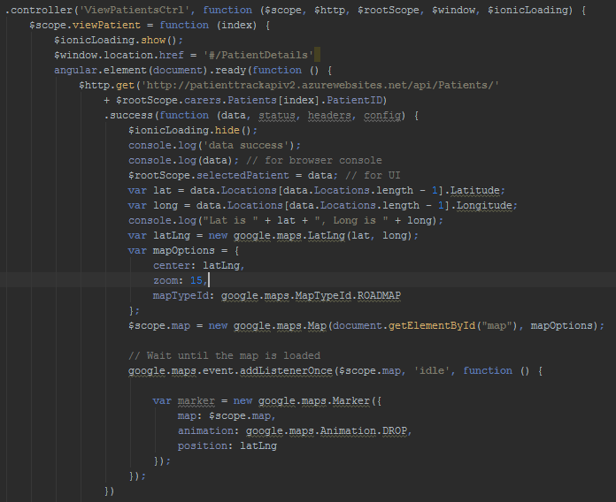

Figure

* + 1. Delete Account

The delete account functionality is contained within a popup. This checks that the password entered in the popup is the same as the carer’s password. Then it makes a DELETE call to the API. And finally, removes the carer’s details from localstorage.

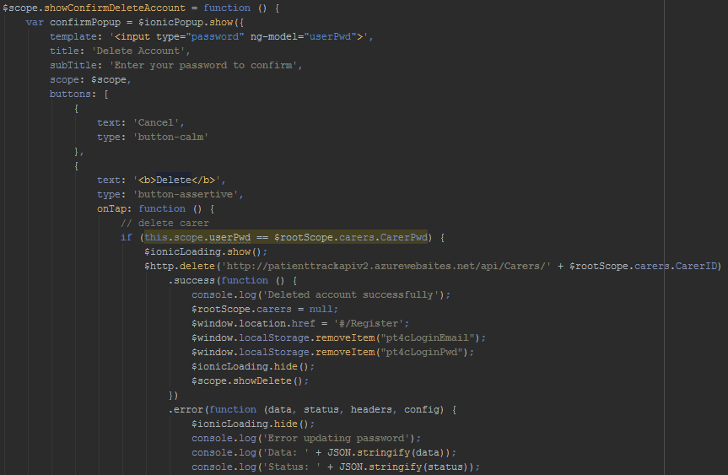

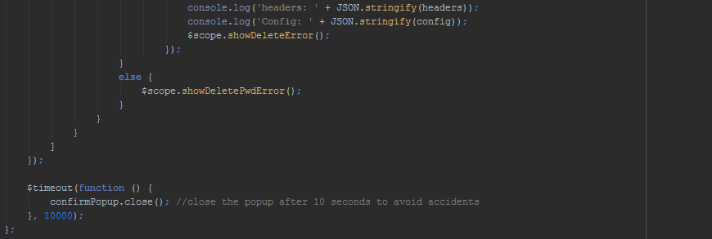

Figure

* + 1. Changing Password

The update password code initially checks that the user has entered their current password correctly (displaying an error popup if not) and then that the new password entries match (displaying a different error popup if not). It then creates the JSON body of the carer object, and creates a PUT request which is sent to the API. Then, the previous password is removed from LocalStorage, and the new password is updated in LocalStorage. Finally, a confirmation message is shown.

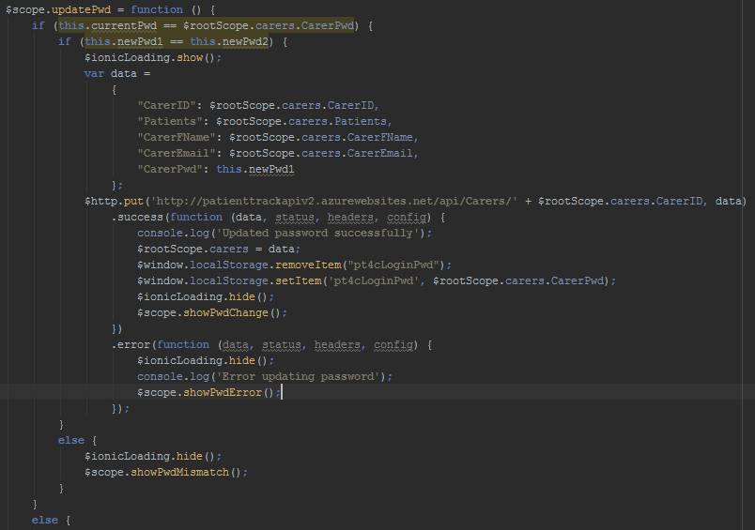



Figure

* 1. PatientTrack for Patients
     1. Patient Code Generation

When a patient registers, a code is generated using their email address. This firstly creates an empty variable, and then creates a 6-character code by using a for loop. Inside this loop, a random character is selected from the email – except for a full-stop - ‘.’ – as this can cause errors in the API when the carer adds a patient.

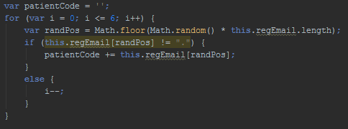

Figure

* + 1. No Data Connection

The following code executes every 30 seconds by using an $interval function. Using the Cordova Diagnostic plugin, the system checks that user has their GPS location enabled, displaying an error message if not. It then checks that the user has an internet connection, displaying another error message if not.

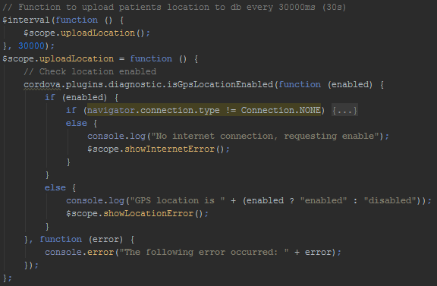

Figure

The following code shows an error popup if the user has no internet connection. This popup explains the issue and then uses the Cordova Diagnostic plugin to either switch the user to either WiFi or Mobile Data settings.

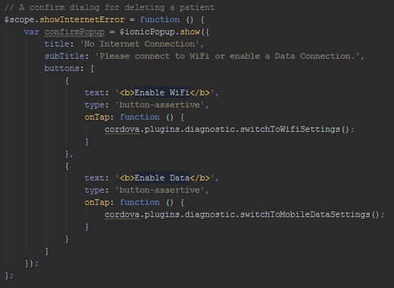

Figure

The following code is called if the user has their location disabled, similar to the code above, it explains the issue and has a button to take the user to their location settings (using the Cordova Diagnostic plugin).

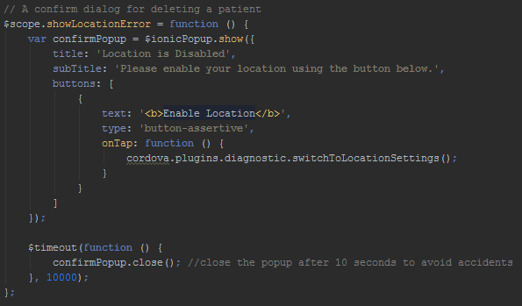

Figure

* + 1. Uploading the location

After checking that the user has Data and Location services enabled, the system uses the Cordova Geolocation plugin to retrieve the user’s current latitude and longitude. These are then posted to the API.

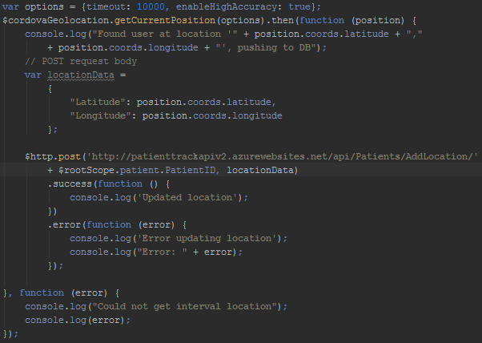

Figure

* + 1. Navigation

When the Home button is clicked, the system gets the user’s current location using the Cordova Geolocation plugin. If the location is successfully retrieved, the system uses the LaunchNavigator plugin to open Google Maps and navigate to the patient’s home location from the patient’s current location.

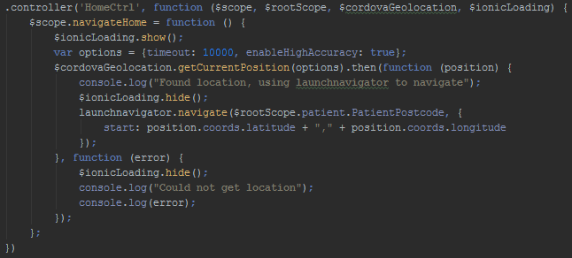

Figure

1. Surveys
   1. Prototype 1

|  |  |  |  |  |  |  |  |  |  |  |
| --- | --- | --- | --- | --- | --- | --- | --- | --- | --- | --- |
| **Question** | **Response** | | | | | | | | | |
| *Which application are you testing?* | PatientTrack for Carers | | | | | | | | | |
| *Which prototype?* | 1 | | | | | | | | | |
| *Which feature are you testing?* | Register & Login | | | | | | | | | |
| *Did it work?* | Yes | | | | | | | | | |
| *On a scale of 1 to 10 (10 being perfect), how well would you say the feature is implemented?* | 1 | 2 | 3 | 4 | 5 | 6 | 7 | 8 | 9 | 10 |
| *On a scale of 1 to 10 (10 being perfect), how usable was this feature?* | 1 | 2 | 3 | 4 | 5 | 6 | 7 | 8 | 9 | 10 |
| *On a scale of 1 to 10 (10 being perfect), how was the performance of this feature?* | 1 | 2 | 3 | 4 | 5 | 6 | 7 | 8 | 9 | 10 |
| *On a scale of 1 to 10 (10 being perfect), how did this feature handle errors?* | 1 | 2 | 3 | 4 | 5 | 6 | 7 | 8 | 9 | 10 |
| *Any comments on improving this feature?* | The API call is a little slow on the first try, but subsequent calls are much quicker.  The error message just says, ‘Error registering’ – some more feedback on possible causes would be very useful. | | | | | | | | | |

|  |  |  |  |  |  |  |  |  |  |  |
| --- | --- | --- | --- | --- | --- | --- | --- | --- | --- | --- |
| **Question** | **Response** | | | | | | | | | |
| *Which application are you testing?* | PatientTrack for Patients | | | | | | | | | |
| *Which prototype?* | 1 | | | | | | | | | |
| *Which feature are you testing?* | Register & Login | | | | | | | | | |
| *Did it work?* | Yes | | | | | | | | | |
| *On a scale of 1 to 10 (10 being perfect), how well would you say the feature is implemented?* | 1 | 2 | 3 | 4 | 5 | 6 | 7 | 8 | 9 | 10 |
| *On a scale of 1 to 10 (10 being perfect), how usable was this feature?* | 1 | 2 | 3 | 4 | 5 | 6 | 7 | 8 | 9 | 10 |
| *On a scale of 1 to 10 (10 being perfect), how was the performance of this feature?* | 1 | 2 | 3 | 4 | 5 | 6 | 7 | 8 | 9 | 10 |
| *On a scale of 1 to 10 (10 being perfect), how did this feature handle errors?* | 1 | 2 | 3 | 4 | 5 | 6 | 7 | 8 | 9 | 10 |
| *Any comments on improving this feature?* | Same issues as encountered in the Carer application. | | | | | | | | | |

* 1. Prototype 2

|  |  |  |  |  |  |  |  |  |  |  |
| --- | --- | --- | --- | --- | --- | --- | --- | --- | --- | --- |
| **Question** | **Response** | | | | | | | | | |
| *Which application are you testing?* | PatientTrack for Carers | | | | | | | | | |
| *Which prototype?* | 2 | | | | | | | | | |
| *Which feature are you testing?* | Adding a patient | | | | | | | | | |
| *Did it work?* | Yes | | | | | | | | | |
| *On a scale of 1 to 10 (10 being perfect), how well would you say the feature is implemented?* | 1 | 2 | 3 | 4 | 5 | 6 | 7 | 8 | 9 | 10 |
| *On a scale of 1 to 10 (10 being perfect), how usable was this feature?* | 1 | 2 | 3 | 4 | 5 | 6 | 7 | 8 | 9 | 10 |
| *On a scale of 1 to 10 (10 being perfect), how was the performance of this feature?* | 1 | 2 | 3 | 4 | 5 | 6 | 7 | 8 | 9 | 10 |
| *On a scale of 1 to 10 (10 being perfect), how did this feature handle errors?* | 1 | 2 | 3 | 4 | 5 | 6 | 7 | 8 | 9 | 10 |
| *Any comments on improving this feature?* | Very well implemented feature – no suggestions to make. | | | | | | | | | |

|  |  |  |  |  |  |  |  |  |  |  |
| --- | --- | --- | --- | --- | --- | --- | --- | --- | --- | --- |
| **Question** | **Response** | | | | | | | | | |
| *Which application are you testing?* | PatientTrack for Patients | | | | | | | | | |
| *Which prototype?* | 2 | | | | | | | | | |
| *Which feature are you testing?* | Viewing patient code | | | | | | | | | |
| *Did it work?* | Yes | | | | | | | | | |
| *On a scale of 1 to 10 (10 being perfect), how well would you say the feature is implemented?* | 1 | 2 | 3 | 4 | 5 | 6 | 7 | 8 | 9 | 10 |
| *On a scale of 1 to 10 (10 being perfect), how usable was this feature?* | 1 | 2 | 3 | 4 | 5 | 6 | 7 | 8 | 9 | 10 |
| *On a scale of 1 to 10 (10 being perfect), how was the performance of this feature?* | 1 | 2 | 3 | 4 | 5 | 6 | 7 | 8 | 9 | 10 |
| *On a scale of 1 to 10 (10 being perfect), how did this feature handle errors?* | 1 | 2 | 3 | 4 | 5 | 6 | 7 | 8 | 9 | 10 |
| *Any comments on improving this feature?* | It would be better if the code was in a bold font as this would make it more obvious to the user | | | | | | | | | |

* 1. Prototype 3

|  |  |  |  |  |  |  |  |  |  |  |
| --- | --- | --- | --- | --- | --- | --- | --- | --- | --- | --- |
| **Question** | **Response** | | | | | | | | | |
| *Which application are you testing?* | PatientTrack for Carers | | | | | | | | | |
| *Which prototype?* | 3 | | | | | | | | | |
| *Which feature are you testing?* | Viewing a patient’s location | | | | | | | | | |
| *Did it work?* | Yes | | | | | | | | | |
| *On a scale of 1 to 10 (10 being perfect), how well would you say the feature is implemented?* | 1 | 2 | 3 | 4 | 5 | 6 | 7 | 8 | 9 | 10 |
| *On a scale of 1 to 10 (10 being perfect), how usable was this feature?* | 1 | 2 | 3 | 4 | 5 | 6 | 7 | 8 | 9 | 10 |
| *On a scale of 1 to 10 (10 being perfect), how was the performance of this feature?* | 1 | 2 | 3 | 4 | 5 | 6 | 7 | 8 | 9 | 10 |
| *On a scale of 1 to 10 (10 being perfect), how did this feature handle errors?* | 1 | 2 | 3 | 4 | 5 | 6 | 7 | 8 | 9 | 10 |
| *Any comments on improving this feature?* | If patient has no locations stored, map is not shown, could maybe use a notification.  Very simple and elegant.  Would be nice if a marker could be dropped on the map for the patient’s exact location (rather than just the map) | | | | | | | | | |

|  |  |  |  |  |  |  |  |  |  |  |
| --- | --- | --- | --- | --- | --- | --- | --- | --- | --- | --- |
| **Question** | **Response** | | | | | | | | | |
| *Which application are you testing?* | PatientTrack for Patients | | | | | | | | | |
| *Which prototype?* | 3 | | | | | | | | | |
| *Which feature are you testing?* | Navigating home | | | | | | | | | |
| *Did it work?* | Yes | | | | | | | | | |
| *On a scale of 1 to 10 (10 being perfect), how well would you say the feature is implemented?* | 1 | 2 | 3 | 4 | 5 | 6 | 7 | 8 | 9 | 10 |
| *On a scale of 1 to 10 (10 being perfect), how usable was this feature?* | 1 | 2 | 3 | 4 | 5 | 6 | 7 | 8 | 9 | 10 |
| *On a scale of 1 to 10 (10 being perfect), how was the performance of this feature?* | 1 | 2 | 3 | 4 | 5 | 6 | 7 | 8 | 9 | 10 |
| *On a scale of 1 to 10 (10 being perfect), how did this feature handle errors?* | 1 | 2 | 3 | 4 | 5 | 6 | 7 | 8 | 9 | 10 |
| *Any comments on improving this feature?* | No errors creatable within the PatientTrack app. If location was not found by Google Maps, a suitable error was displayed by their app. Worked very well. Could do with home button being larger. | | | | | | | | | |

* 1. Prototype 4

|  |  |  |  |  |  |  |  |  |  |  |
| --- | --- | --- | --- | --- | --- | --- | --- | --- | --- | --- |
| **Question** | **Response** | | | | | | | | | |
| *Which application are you testing?* | PatientTrack for Carers | | | | | | | | | |
| *Which prototype?* | 4 | | | | | | | | | |
| *Which feature are you testing?* | Updating a patient’s address | | | | | | | | | |
| *Did it work?* | Yes | | | | | | | | | |
| *On a scale of 1 to 10 (10 being perfect), how well would you say the feature is implemented?* | 1 | 2 | 3 | 4 | 5 | 6 | 7 | 8 | 9 | 10 |
| *On a scale of 1 to 10 (10 being perfect), how usable was this feature?* | 1 | 2 | 3 | 4 | 5 | 6 | 7 | 8 | 9 | 10 |
| *On a scale of 1 to 10 (10 being perfect), how was the performance of this feature?* | 1 | 2 | 3 | 4 | 5 | 6 | 7 | 8 | 9 | 10 |
| *On a scale of 1 to 10 (10 being perfect), how did this feature handle errors?* | 1 | 2 | 3 | 4 | 5 | 6 | 7 | 8 | 9 | 10 |
| *Any comments on improving this feature?* | The user can enter any text value for the address, which could be problematic for the patient when using navigation. Would be ideal if there was some validation on the address. | | | | | | | | | |

|  |  |  |  |  |  |  |  |  |  |  |
| --- | --- | --- | --- | --- | --- | --- | --- | --- | --- | --- |
| **Question** | **Response** | | | | | | | | | |
| *Which application are you testing?* | PatientTrack for Patients | | | | | | | | | |
| *Which prototype?* | 4 | | | | | | | | | |
| *Which feature are you testing?* | Changing username and password | | | | | | | | | |
| *Did it work?* | Yes | | | | | | | | | |
| *On a scale of 1 to 10 (10 being perfect), how well would you say the feature is implemented?* | 1 | 2 | 3 | 4 | 5 | 6 | 7 | 8 | 9 | 10 |
| *On a scale of 1 to 10 (10 being perfect), how usable was this feature?* | 1 | 2 | 3 | 4 | 5 | 6 | 7 | 8 | 9 | 10 |
| *On a scale of 1 to 10 (10 being perfect), how was the performance of this feature?* | 1 | 2 | 3 | 4 | 5 | 6 | 7 | 8 | 9 | 10 |
| *On a scale of 1 to 10 (10 being perfect), how did this feature handle errors?* | 1 | 2 | 3 | 4 | 5 | 6 | 7 | 8 | 9 | 10 |
| *Any comments on improving this feature?* | No actual errors encountered. However, it would be very useful to have a ‘Forgot password’ feature on the login page | | | | | | | | | |

1. Test logs
   1. Prototype 1
      1. PatientTrack for Patients

|  |  |  |  |  |  |
| --- | --- | --- | --- | --- | --- |
| **Test No.** | **Test Description** | **Expected Outcome** | **Actual Outcome** | **Pass / Fail** | **Action Taken** |
| **Registration Page** | | | | | |
| 1 | Leave all text boxes blank on registration | User is not registered and an error message is displayed | As expected | Pass | None |
| 2 | Leave username blank | User is not registered and an error message is displayed | As expected | Pass | None |
| 3 | Leave email blank | User is not registered and an error message is displayed | As expected | Pass | None |
| 4 | Leave password blank | User is not registered and an error message is displayed | User was successfully registered with a blank password | Fail | Add check that password text is not blank before registration attempt. This was implemented by adding a ‘required’ label to each of the input boxes in the form. Then adding an ‘ng-disabled’ on the register button if the form is invalid. This will also be applied to all other forms in the project to avoid similar errors. |
| 5 | Leave address blank | User is not registered and an error message is displayed | As expected | Pass | None |
| 7 | Entering valid details | User will be registered, confirmation alert displayed and transferred to login page. Registration details cleared | As expected | Pass | None |
| **Login Page** | | | | | |
| 8 | Leaving all text boxes blank | Login button disabled so cannot be clicked | As expected | Pass | None |
| 9 | Leave email blank | Login button disabled so cannot be clicked | As expected | Pass | None |
| 10 | Leave password blank | Login button disabled so cannot be clicked | As expected | Pass | None |
| 11 | Entering valid details | User will be redirected to home page and have their name displayed | As expected | Pass | None |

* + 1. PatientTrack for Carers

|  |  |  |  |  |  |
| --- | --- | --- | --- | --- | --- |
| **Test No.** | **Test Description** | **Expected Outcome** | **Actual Outcome** | **Pass / Fail** | **Action Taken** |
| **Registration Page** | | | | | |
| 1 | Leave all text boxes blank on registration | User is not registered and an error message is displayed | As expected | Pass | None |
| 2 | Leave username blank | User is not registered and an error message is displayed | As expected | Pass | None |
| 3 | Leave email blank | User is not registered and an error message is displayed | As expected | Pass | None |
| 4 | Leave password blank | User is not registered and an error message is displayed | As expected | Pass | None |
| 5 | Leave address blank | User is not registered and an error message is displayed | As expected | Pass | None |
| 7 | Entering valid details | User will be registered, confirmation alert displayed and transferred to login page. Registration details cleared | As expected | Pass | None |
| **Login Page** | | | | | |
| 8 | Leaving all text boxes blank | Login button disabled so cannot be clicked | As expected | Pass | None |
| 9 | Leave email blank | Login button disabled so cannot be clicked | As expected | Pass | None |
| 10 | Leave password blank | Login button disabled so cannot be clicked | As expected | Pass | None |
| 11 | Entering valid details | User will be redirected to home page and have their name displayed | As expected | Pass | None |

* 1. Prototype 2
     1. PatientTrack for Patients

|  |  |  |  |  |  |
| --- | --- | --- | --- | --- | --- |
| **Test No.** | **Test Description** | **Expected Outcome** | **Actual Outcome** | **Pass / Fail** | **Action Taken** |
| **Home Page** | | | | | |
| 1 | User can access settings page using settings icon in navbar | Button links to settings page | As expected | Pass | None |
| **Settings Page** | | | | | |
| 2 | User can view their unique patient code | Patient code is displayed at the top of the settings page | As expected | Pass | None |

* + 1. PatientTrack for Carers

|  |  |  |  |  |  |
| --- | --- | --- | --- | --- | --- |
| **Test No.** | **Test Description** | **Expected Outcome** | **Actual Outcome** | **Pass / Fail** | **Action Taken** |
| **Home Page** | | | | | |
| 1 | User can access the Add Patient alter box using a plus icon in the home page’s navbar | Clicking plus button opens the add patient dialog | As expected | Pass | None |
| 2 | Entering a code not associated with a patient | Does not add a patient and displays a ‘not found’ error message | As expected | Pass | None |
| 3 | Entering a blank code | Does not add a patient and displays a ‘not found’ error message | As expected | Pass | None |
| 4 | Entering a valid patient code | Displays a success message and patient is added to home screen | As expected | Pass | None |
| 5 | Entering a valid patient code with whom a connection already exists | Displays an error message | As expected | Pass | None |
| 6 | Home screen lists all patients on login | All patients which have connected with the carer are displayed in a list | As expected | Pass | None |

* 1. Prototype 3
     1. PatientTrack for Patients

|  |  |  |  |  |  |
| --- | --- | --- | --- | --- | --- |
| **Test No.** | **Test Description** | **Expected Outcome** | **Actual Outcome** | **Pass / Fail** | **Action Taken** |
| 1 | Patient’s app sends location to DB every 30 seconds | Location is uploaded to DB along with current time | As expected | Pass | None |
| 2 | Patient is not affected by location uploading | When uploading location: No delay in using app, no change of display | As expected | Pass | None |
| 3 | If patient has location disabled | No location is uploaded, and the patient is shown a message asking them to enable it, with the option to transfer to the location settings page | No alert box displayed | Fail | Created an alert which uses the Cordova diagnostic plugin to check the location and switch user to location options |
| 4 | If patient has no internet connection | No location is uploaded, and the patient is shown a message asking them to enable their WiFi or data, with the option to transfer to the relevant settings page | No alert box displayed | Fail | Created an alert which uses the Cordova network information plugin to check the connection and switch user to WiFi or Data options |
| 5 | If patient has no internet connection and location disabled | No location is uploaded. Patient is shown two messages, one to request location enabled, and one to request data or WiFi to be enabled | As expected | Pass | None |
| 6 | Navigation | Upon clicking the large ‘Home’ button on the home page, the user is redirected to Google Maps, and is shown options for their route to their stored address | As expected | Pass | None |
| 7 | Navigation with an invalid address | If the user’s address is invalid, and cannot be found by Google Maps, they are not displayed a route, however do have the option to re-enter the target location. | As expected | Pass | None |

* + 1. PatientTrack for Carers

|  |  |  |  |  |  |
| --- | --- | --- | --- | --- | --- |
| **Test No.** | **Test Description** | **Expected Outcome** | **Actual Outcome** | **Pass / Fail** | **Action Taken** |
| **Home page** | | | | | |
| 1 | Viewing a patient’s details | Clicking on a patient from the list of patients opens the patient’s details page. | As expected | Pass | None |
| **Patient Details Page** | | | | | |
| 2 | Viewing patient’s most recent details | Upon opening a patient’s details page, the user is displayed the most recent location of the patient on a Google Map widget, along with the time of the location. The user is also displayed the patient’s name, home address, and email address. | As expected | Pass | None |
| 3 | The map is interactive | The user can zoom in/out on the map, can drag the map, and can use Google Street View to better understand the location of the patient. | As expected | Pass | None |
| 4 | The details are updated each time the page is viewed | Each time the user loads the patient details page it should be updated to ensure the location displayed is the most recent | As expected | Pass | None |
| 5 | The patient has no recorded locations | If the patient has no recorded locations, the map is not displayed | As expected | Pass | None |

* 1. Prototype 4
     1. PatientTrack for Patients

|  |  |  |  |  |  |
| --- | --- | --- | --- | --- | --- |
| **Test No.** | **Test Description** | **Expected Outcome** | **Actual Outcome** | **Pass / Fail** | **Action Taken** |
| **Settings Page** | | | | | |
| 1 | Updating Username with valid text | The user can update their username | As expected | Pass | None |
| 2 | Updating username with empty text | The update button is not enabled, so the username is not updated | As expected | Pass | None |
| 4 | Viewing the privacy policy | The user can click the ‘View Privacy Policy’ button to navigate to the privacy policy page. | As expected | Pass | None |
| 5 | Viewing the help page | The user can click the ‘Help’ button to navigate to the help page. | As expected | Pass | None |
| 6 | Viewing the change password page | The user can go to the change password page by clicking on the appropriate button | As expected | Pass | None |
| 7 | Attempting to delete account with the wrong password | User is shown an ‘incorrect password’ error message | As expected | Pass | None |
| 8 | Attempting to delete account with no password entered | User is shown an ‘incorrect password’ error message | As expected | Pass | None |
| 9 | Attempting to delete account using correct password, when patient’s account is connected with carers | Account is not deleted, user is shown an error message stating that they cannot delete their account whilst connected with carers, along with a list of their current carers | User is shown an ‘incorrect password’ error message | Fail | Add functionality to display carers if patient has one or more carers associated. |
| 10 | User leaves the ‘delete account’ alert box open for more than 10 seconds | The box automatically closes to avoid accidental deletion | As expected | Pass | None |
| 11 | User clicks on sign out | User is signed out, login details are removed from local storage, and user is redirected to the login page | As expected | Pass | None |
| 12 | User is signed in, closes the app, and clears the cache, then reopens the app | The app should retrieve their details from local storage, and automatically log them in. | As expected | Pass | None |
| **Change Password Page** | | | | | |
| 13 | The user enters their current password incorrectly | The user is shown a ‘current password incorrect’ error message | As expected | Pass | None |
| 14 | The new password entries do not match | The user is shown a ‘New password entries do not match’ error message | As expected | Pass | None |
| 15 | The user leaves the form blank | The form is not valid so the save button is not enabled | As expected | Pass | None |
| 16 | The user enters the correct current password, but leaves the new password boxes blank | The form is not valid so the save button is not enabled | As expected | Pass | None |
| 17 | The user enters their correct current password, and two matching valid entries for their new password | The user’s password is changed, including in local storage – so that closing the app and reopening signs them in automatically | As expected | Pass | None |

* + 1. PatientTrack for Carers

|  |  |  |  |  |  |
| --- | --- | --- | --- | --- | --- |
| **Test No.** | **Test Description** | **Expected Outcome** | **Actual Outcome** | **Pass / Fail** | **Action Taken** |
| **Settings Page** | | | | | |
| 1 | Updating Username with valid text | The user can update their username | As expected | Pass | None |
| 2 | Updating username with empty text | The update button is not enabled, so the username is not updated | As expected | Pass | None |
| 3 | Viewing the privacy policy | The user can click the ‘View Privacy Policy’ button to navigate to the privacy policy page. | As expected | Pass | None |
| 4 | Viewing the help page | The user can click the ‘Help’ button to navigate to the help page. | As expected | Pass | None |
| 5 | Viewing the change password page | The user can go to the change password page by clicking on the appropriate button | As expected | Pass | None |
| 6 | Attempting to delete account with the wrong password | User is shown an ‘incorrect password’ error message | As expected | Pass | None |
| 7 | Attempting to delete account with no password entered | User is shown an ‘incorrect password’ error message | As expected | Pass | None |
| 8 | User leaves the ‘delete account’ alert box open for more than 10 seconds | The box automatically closes to avoid accidental deletion | As expected | Pass | None |
| 9 | User enters correct password on delete account | Account is deleted and user is redirected to the Registration page | As expected | Pass | None |
| 10 | User clicks on sign out | User is signed out, login details are removed from local storage, and user is redirected to the login page | As expected | Pass | None |
| 11 | User is signed in, closes the app, and clears the cache, then reopens the app | The app should retrieve their details from local storage, and automatically log them in. | As expected | Pass | None |
| **Change Password Page** | | | | | |
| 12 | The user enters their current password incorrectly | The user is shown a ‘current password incorrect’ error message | As expected | Pass | None |
| 13 | The new password entries do not match | The user is shown a ‘New password entries do not match’ error message | As expected | Pass | None |
| 14 | The user leaves the form blank | The form is not valid so the save button is not enabled | As expected | Pass | None |
| 15 | The user enters the correct current password, but leaves the new password boxes blank | The form is not valid so the save button is not enabled | As expected | Pass | None |
| 16 | The user enters their correct current password, and two matching valid entries for their new password | The user’s password is changed, including in local storage – so that closing the app and reopening signs them in automatically | As expected | Pass | None |
| **Patient Settings Page** | | | | | |
| 17 | User enters a valid address for the patient’s address | Patient’s address is updated, the carer is asked to confirm that the patient’s app sends them to the correct address | As expected | Pass | None |
| 18 | User enters an invalid address for the patient’s address | The patient’s address is not updated | The patient’s address is updated | Fail | This falls under future development, validation of address |
| 19 | User leaves the address box blank | The save button is disabled | As expected | Pass | None |
| 20 | User clicks on Delete patient button and then on Cancel | The carer-patient connection is not altered | As expected | Pass | None |
| 21 | User clicks on Delete patient and then on ‘OK’ | Patient connection is deleted, user is notified of this and returned to updated patient list | As expected | Pass | None |

1. Project Proposal

**COMP1682 Project Proposal**

**An Investigation in the use of Mobile Applications with Location Tracking to improve the quality of life for Dementia Patients and their Carers**

**Joseph Schofield**

**BSc Computing**

**000776975**

**1 Overview**

According to the Alzheimer Society (2016), *“there are 850,000 people with dementia in the UK, with numbers set to rise to over 1 million by 2025”*. As the number of patients increases, so does the pressure on their carers (Cipriani et al, 2014), therefore something must be done to reduce the workload of a Dementia carer. This project will investigate how we utilise technology to assist the lives of Dementia sufferers and their patients to determine what more we can do with it. Currently people suffering from Dementia are very dependent on their carers as the disease can cause them to get confused and lost quite easily (Holzer & Warshaw, 2009). Furthering this point, Kwok et al (2009), wrote *“patients with greater cognitive decline and continued mobility are at greater risk of getting lost”*. Cipriani et al (2014), calculated that 1 in 5 (20%) people with Dementia wander, whereas Kwok et al (2009), state that *“their data showed that 37.7% of the patients had history of wandering”.* While it is arguable that the figure may have declined since 2009, there is no doubt that wandering remains a serious issue, causing increased morbidity or even mortality (Cipriani et al, 2014).

This project intends to investigate how severely this issue affects the day to day life of Dementia sufferers and their carers. It will also explore any other issues which have not yet had solutions created. A solution to these issues will be found by analysing the many white papers and articles available and finding common issues (Dementia sufferers should not be contacted directly as it is not ethically viable). From discovery of these issues I will design an application which resolves them (or reduces their effect), beginning with the most important issue first. Once a solution has been determined and created it can be evaluated by comparing qualities of the application to similar applications - testing features such as ease of use, simplicity of design and returning to the original problem domain to test that the issues are resolved by the application.

**Keywords:** Android, Application, Dementia, Location-tracking, Smartphone, Assistive Technologies

**2 Aim**

This project aims to explore the current issues surrounding Dementia sufferers and their carers to gather requirements to develop an Android application which will simplify the process of caring for the Dementia sufferers.

**3 Objectives**

|  |  |  |
| --- | --- | --- |
| **3.1** | **Research** | |
|  | 3.1.1 | Gain an improved understanding of Android development and Dementia to understand what application would be useful |
|  | 3.1.2 | Read papers relevant to Android Development using location services. [1] |
|  | 3.1.3 | Read papers relevant to the use of technology with Dementia sufferers. [1] |
|  | 3.1.4 | Read papers detailing the issues that Dementia Patient Carers encounter. [1] |
|  | 3.1.5 | Research papers and websites to discover legal issues surround Android applications. [0.5] |
|  | 3.1.6 | Research ethical issues surrounding working with Dementia sufferers. [0.5] |
|  | 3.1.7 | Find similar mobile applications currently available and determine how my solution is different. [1] |
|  | 3.1.8 | Review Android user interface design documentation [1] |
|  | 3.1.9 | Review Android user interface design issues [0.5] |
| **3.2** | **Design Documentation** | |
|  | 3.2.1 | Fully design the application using UML diagrams and high-fidelity prototyping. |
|  | 3.2.2 | Create a Statement of Requirements [2] |
|  | 3.2.3 | Design a high-fidelity prototype on paper [0.5] |
|  | 3.2.4 | Create Use Case diagram with at least 5 use cases [1.5] |
|  | 3.2.5 | Create Class Diagram [0.5] |
|  | 3.2.6 | Create State Diagram [0.5] |
|  | 3.2.7 | Design database [0.5] |
| **3.3** | **Implementation** | |
|  | 3.3.1 | Develop the Android applications. |
|  | 3.3.2 | Create a GitHub repository and set up local workspace [0.1] |
|  | 3.3.3 | Create simple web database for storing user details (details decided in design phase) [0.5] |
|  | 3.3.4 | Create blank project in Android Studio for smartphone platform [0.1] |
|  | 3.3.5 | Develop applications using TDD (using MoSCoW prioritisation to decide which functions are developed first) [20] |
|  | 3.3.6 | Commence black-box testing, keep unit tests up to date [5] |
| **3.4** | **Evaluation Report** | |
|  | 3.4.1 | Critically evaluate the final product. |
|  | 3.4.2 | Check that requirements have been met, and explain reasons for any that haven’t. [2] |
|  | 3.4.3 | Describe any future developments of the application [0.5] |
|  | 3.4.4 | Explain any changes I would have liked to make to the finished product [0.5] |

**4 Legal, Social, Ethical, and Professional**

In this section I will describe the various legal, social, and ethical issues surrounding my project area and explain how I will address them in a professional manner.

**Legal**

**Data Protection Act**

According to Gov.uk (2016), The Data Protection Act (1998) requires that businesses which store personal information must “keep it safe and secure”. Therefore, I must protect my database from SQL injection, use secure passwords and ensure that all connections are closed after they have been used.

**Copyright**

Google (2016), have set out very clear guidelines around copyright infringement and have a process for removing apps and developer accounts which have broken these laws. Therefore, Intellectual Property (IP) theft is not a concern. However, I must be diligent that my app does not infringe upon the work of others.

**Privacy Policy**

Every mobile app requires a Privacy Policy. Iubenda (2016), describes a privacy policy as *“a statement of your data collection as a disclosing service to your visitors or users”.* They then go on to describe EU laws surrounding Privacy Policies; the Data Protection Directive and the ePrivacy Directive. To comply with these laws, I will ensure that my project’s app will have a clear, specific and thorough privacy which is accessible within the app itself.

**Social**

**Reducing Pressure on Carers**

Looking after someone with Dementia is a very taxing task. This project aims to develop an application which will track the patient and give them simple access to navigation (with Google Maps) to guide them home if lost. This will significantly reduce the workload of the carer and enable them to care for several patients remotely if required.

**Reducing Risks for People with Dementia**

As stated in the Overview, wandering is a serious issue, causing increased morbidity or even mortality (Cipriani et al, 2014). Therefore, giving the patient access to a simple means of navigation may enable them to avoid dangerous situations.

**Easing Worries for Family Members**

Family members may live away from their relative with dementia, and naturally will worry that they have gone wandering and are lost or injured. With the application developed as a product of this project the family will be able to track the location of their relative to ensure that they are in a safe place.

**Ethical**

**Tracking**

Tracking the location of a device remotely may be seen as intrusive and could be abused if used improperly or if the location is accessed from an unauthorized device. Therefore, in the application it will clearly state who is able to track the device and there will be security measures to ensure that only authorized users can discover the device.

**Data Use**

The target audience for the application developed from this project will be Dementia sufferers and their carers. As Dementia sufferers are particularly vulnerable in comparison to the average app user I must ensure that I am entirely ethical in the way I use their data. Laws aside, it would be entirely unethical to share any personal information such as addresses, names and locations of the users - therefore I must ensure that if they are required then they are stored securely, and that I do not store any information which is not required.

**Software Bugs**

Software bugs can, depending on their severity, make the software unusable. According to WebMD, the median age of a Dementia sufferer is 83 years old - meaning it’s quite likely that they do not have much experience with using technology. Therefore, I will aim to produce an app which is entirely bug free and easy to use.

**Payment**

Medical care can be very expensive. The Alzheimer’s Society (2014), states that the average annual cost of a person with dementia is £32,250, and that two thirds of this must be paid for by people with Dementia and their families. To avoid costing the Dementia patients, their families and charities any more than they already spend on healthcare I will be making this application entire free.

**System Abuse**

The application I create will be connected to a database, and therefore vulnerable to SQL injection. I will have to ensure that any connections made are securely closed and sufficiently password protected.

The application will also have the functionality to remotely track another device - therefore I must create connections securely between devices to ensure that only an authorised user can track the device.

**User Interaction**

With most applications the testing process requires contact with the intended audience. However it would not be very ethical to test the app on people with Dementia as they may find the experience distressing. Therefore, for any requirements gathering, manual testing, and surveys of the application I will enlist the help of fellow students as they will sufficiently be able to test the usability and functionality and I will not require ethical clearance.

**5 Planning**

I will be using iterative development as this will allow for changes to be made to the requirements and design of the application. I intend to use various Agile practises to develop my product. Many of these are encapsulated within DSDM. These include:

**TDD**

TDD using an Android Java testing framework such as AndroidJUnitRunner or Espresso as in the past I have found that this method of development produces more bug-free, cleaner and more readable code. I have also found that, although it means writing additional code for testing, it does not affect the speed of development as it is usually clearer what code needs to be written.

**MoSCoW Prioritisation**

Once I have gathered a comprehensive list of requirements for the application I will prioritise these using the MoSCoW method to decide which functionalities I should develop first. Enabling the development of the less fundamental requirements if there is time.

**MVP**

I will create a statement describing the Minimum Viable Product (MVP). This will be useful for determining if I have created a suitable application in my critical evaluation.

**Time-boxing**

I will use time-boxing to set out how long I will spend on each objective. This, if adhered to properly, will ensure that all necessary functionalities, tests and documents are implemented within the time bounds of the course. I will then present these in a Gantt chart as a visual representation can help to show any improper time estimates.

**GitHub/Zenhub**

I will use GitHub for source control as this is secure, cloud-based and easy to use. I will also use an add-on for GitHub, ZenHub, for task management as this has a visual representation similar to a Kanban board.

**6 References**

1. Alzheimer's Society. 2016. *Facts for the Media*. [ONLINE] Available at:<https://www.alzheimers.org.uk/site/scripts/documents_info.php?documentID=535&pageNumber=2>. [Accessed 17 October 2016].
2. Holzer, C., Warshaw, G., *Clues to Early Alzheimer Dementia in the Outpatient Setting*. Arch Fam Med 9: 1066–1070. 2009.
3. Kwok, T., Yuen, K., Ho, F., Chan, W., *Getting Lost in the Community: a Phone Survey on the Community-Dwelling Demented People in Hong Kong*. International Journal of Geriatric Psychiatry. 25: 427-432. 2009.
4. Cipriani, G., Lucetti, C., Nuti, A., Danti, S., *Wandering and Dementia*. PSYCHOGERIATRICS. 14: 135-142. 2014.
5. Gov.uk. 2016. *Data Protection*. [ONLINE] Available at: <https://www.gov.uk/data-protection/the-data-protection-act>. [Accessed 19 October 2016].
6. Google. 2016. *Unauthorised Use of Copyrighted Content | Intellectual Property, Deception, and Spam*. [ONLINE] Available at: <https://play.google.com/about/ip-deception-spam/impersonation-ip/unauthorized-copyright/>. [Accessed 19 October 2016].
7. iubenda. 2016. *Privacy & Cookie Policy Generator - for Websites and Apps | iubenda*. [ONLINE] Available at: [https://www.iubenda.com/en/](https://www.iubenda.com/en/mobile). [Accessed 19 October 2016].
8. WebMD. 2016. *Average Dementia Survival: 4.5 Years*. [ONLINE] Available at:<http://www.webmd.com/alzheimers/news/20080110/average-dementia-survival?page=2>. [Accessed 19 October 2016].
9. Alzheimer's Society. 2014. *Financial Cost of Dementia - Alzheimer's Society*. [ONLINE] Available at:<https://www.alzheimers.org.uk/site/scripts/documents_info.php?documentID=418>. [Accessed 19 October 2016].

**7 Bibliography**

1. Google. 2016. *Testing Support Library*. [ONLINE] Available at:<https://developer.android.com/topic/libraries/testing-support-library/index.html>. [Accessed 16 October 2016].
2. Google. 2016. *Developer Policy Centre*. [ONLINE] Available at: <https://play.google.com/about/developer-content-policy/>. [Accessed 17 October 2016].
3. Hadjioannou, V., Markakis, E., Mastorakis, G., Mavromoustakis, C., Pallis, E., Valavani, D., *Context Awareness Location-based Android Application for Tracking Purposes in Assisted Living.* International Conference on Telecommunications and Multimedia (TEMU). 2016.
4. Oh, H., Gross, M., *Awareable Steps: Functional and Fashionable Shoes for Patients with Dementia.* UBICOMP/ISWC ‘15 ADJUNCT, SEPTEMBER 7-11, 2015, OSAKA, JAPAN. p579-583. 2015.
5. Sasaki, H., *A Smartphone App Provides Preventative Care for the Elderly with Dementia\**. IEEE 32nd International Conference on Data Engineering Workshops (ICDEW), p50-53. 2016.
6. SCL. 2012. *Legal Issues for App Developers*. [ONLINE] Available at: <http://www.scl.org/site.aspx?i=ed27592>. [Accessed 17 October 2016].
7. Zenhub. 2016. *Turn GitHub into a robust project management platform*. [ONLINE] Available at:<https://www.zenhub.com/>. [Accessed 17 October 2016].
8. Wick JY, Zanni GR. *Aimless excursions: wandering in the elderly.* Consult Pharm. 21: 608–612, 615–618. 2006.
9. Sakurai, S., Onishi, J., Hirai, M., *Impaired Autonomic Nervous System Activity During Sleep in Family Caregivers of Ambulatory Dementia in Japan.* Biological Research for Nursing, 17: 21-28. 2014.